**Setting up Transit Gateway and VPC Endpoints for a Multi-VPC Architecture**

Scenario: A large organization is migrating its on-premises infrastructure to the AWS cloud. The organization's architecture involves multiple VPCs for different departments and applications, each requiring secure communication with centralized services and external resources. The IT team needs to design and implement a scalable and efficient network architecture to accommodate the organization's growth and ensure robust connectivity between VPCs and external services.

Objectives: Design and deploy a scalable network architecture using AWS Transit Gateway to simplify network connectivity between multiple VPCs. Configure VPC endpoints to securely access AWS services without internet gateways or NAT gateways, ensuring data privacy and minimizing exposure to external threats.

Design and deploy a scalable network architecture using AWS Transit Gateway to simplify network connectivity between multiple VPCs

**4 regions**

**Oregon us-west-2**

**Tokyo ap-northeast-1**

**Frankfurt eu-central-1**

**Paris eu-west-3**

**Oregon us-west-2**

To set uo Tansit Gateway and VPC endpoints for a multi VPC Architecture

I have selected 4 regions in AWS

1. Oregon : us-west-2

2. Tokyo : ap-northeast-1

3. Frankfurt: eu-central-1

4. Paris: eu-west-3

Considering oregon as hub and spoke region for remaining regions

Consider Oregon region

Create VPC

Go to Amazon AWS console in that select VPC

select create VPC

Name: vpc-hub-oregon

CIDR: 10.0.0.0/16

Create internet gateway and attach vpc created

Create Subnets:

Public subnet :10.0.1.0/24

Private subnet:10.0.2.0/24

Create Transit Gateway

Configure transit gateway with default ASN number 64512

Now go to Transit Gateway attachments and create 1 attachment with created vpc-hub-oregon

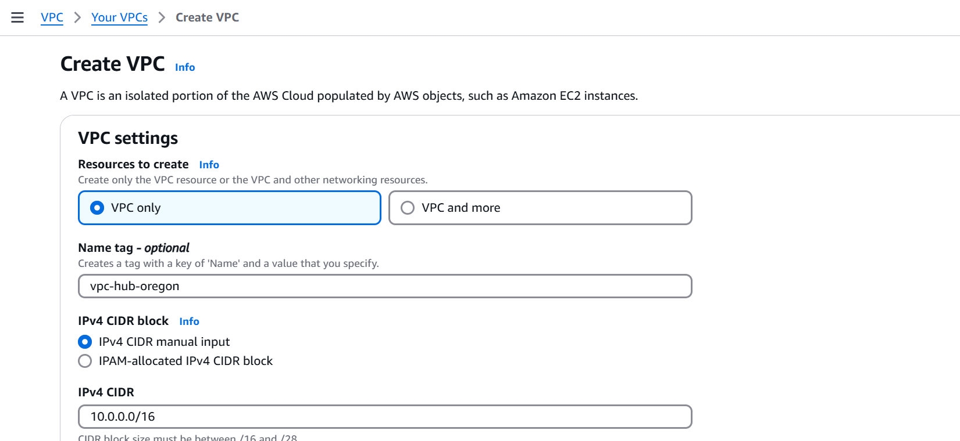

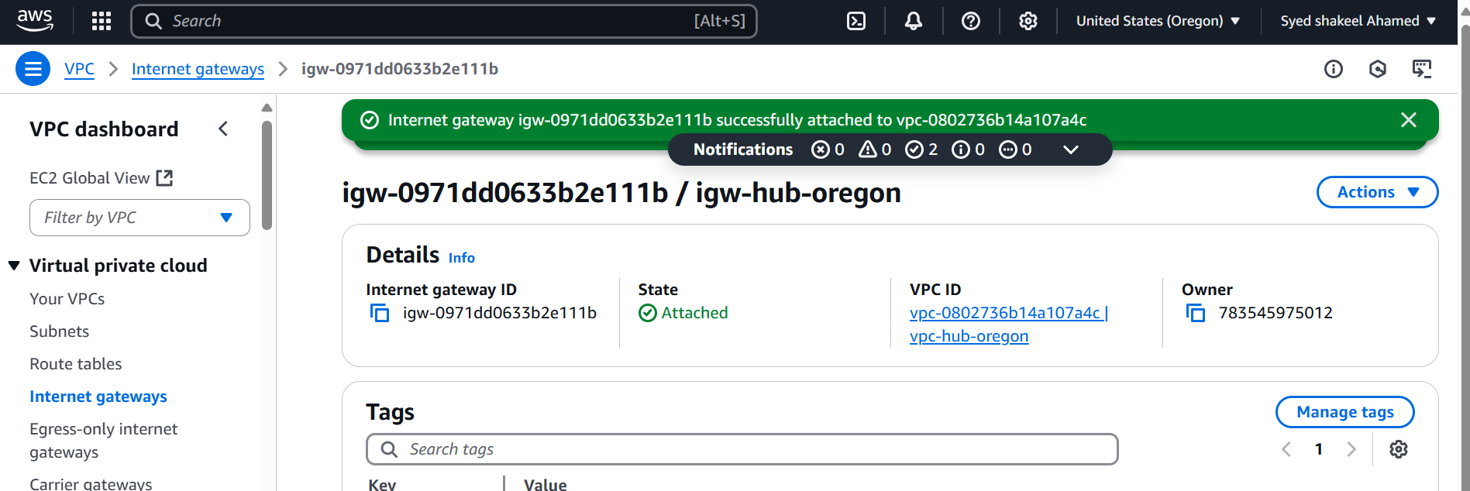

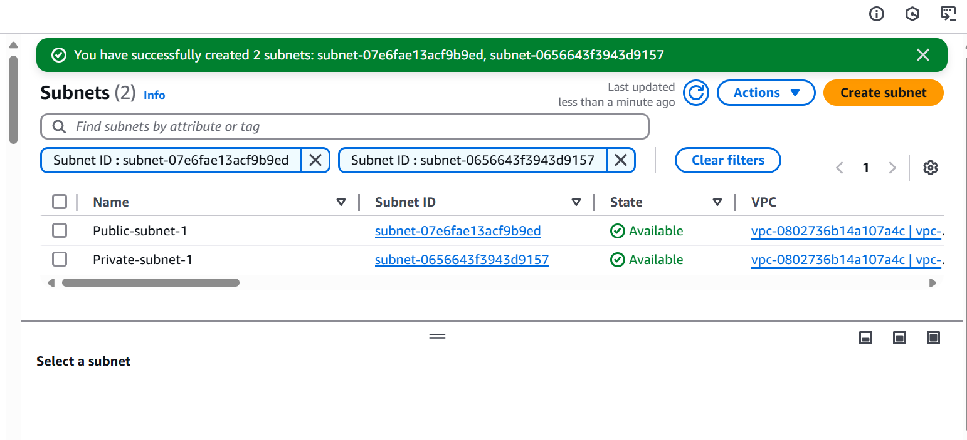

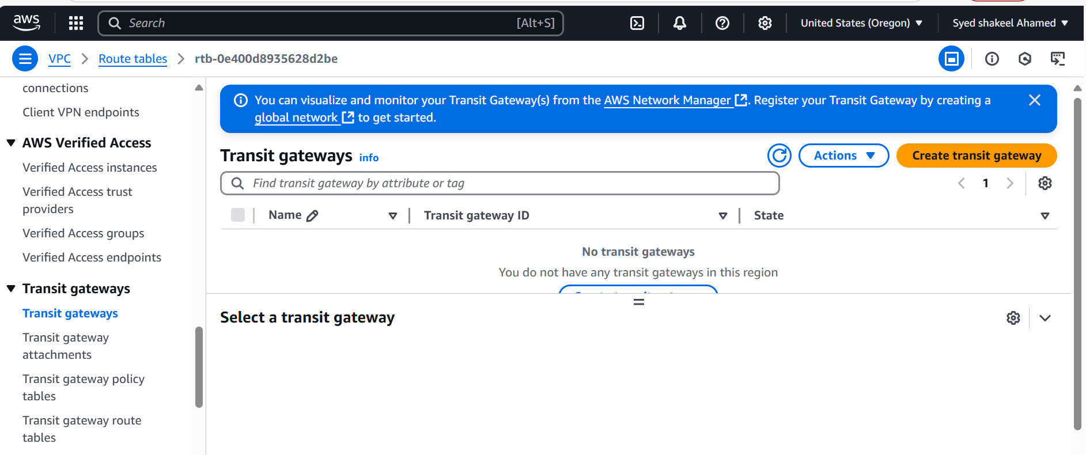

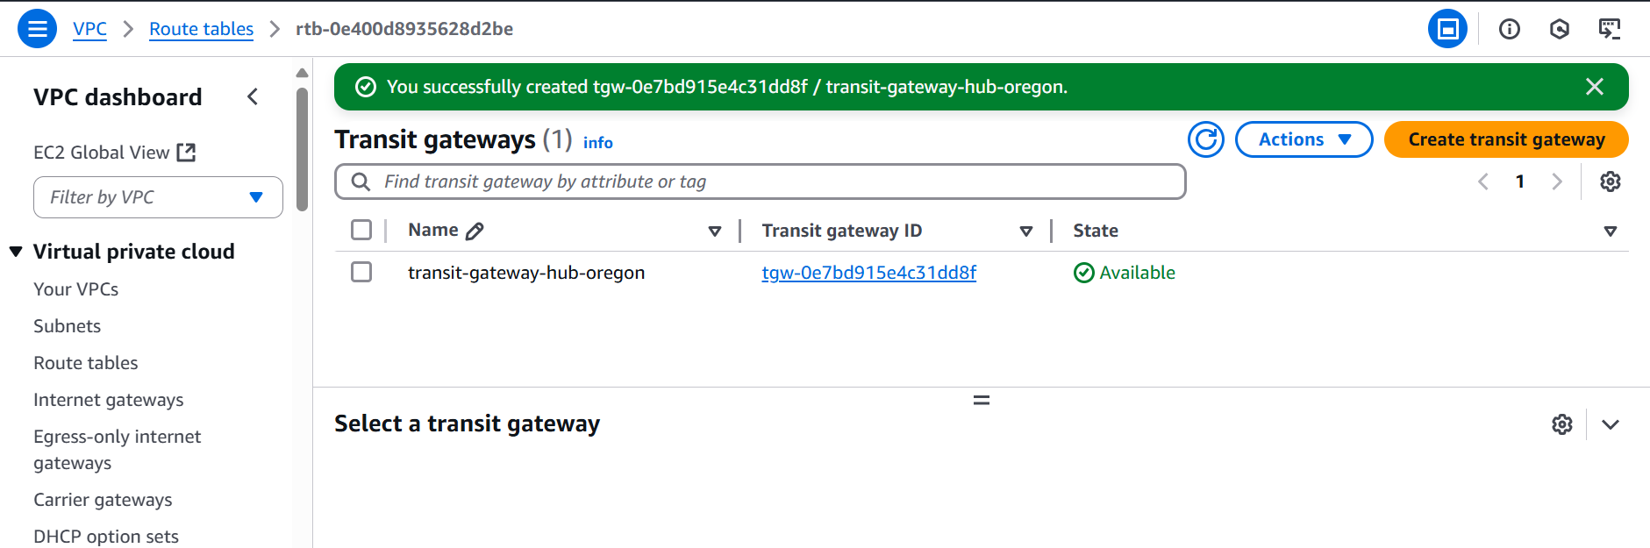

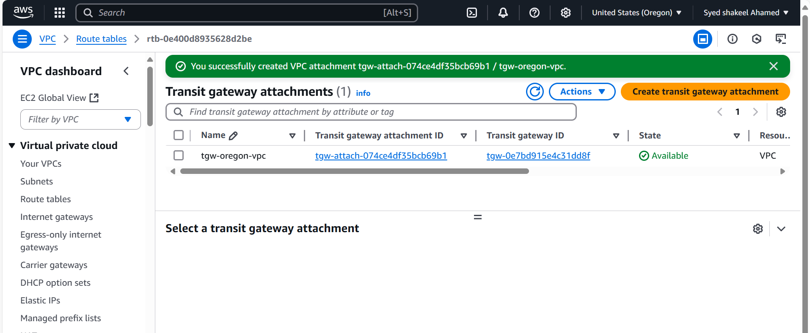

**Tokyo ap-northeast-1**

Create VPC

Go to Amazon AWS console in that select VPC

select create VPC

Name: vpc-tokyo

CIDR: 11.0.0.0/16

Create internet gateway and attach vpc created

Create Subnets:

Public subnet :11.0.1.0/24

Private subnet:11.0.2.0/24

Create Transit Gateway

Configure transit gateway with default ASN number 64513

Now go to Transit Gateway attachments and create 1 attachment with created vpc-tokyo

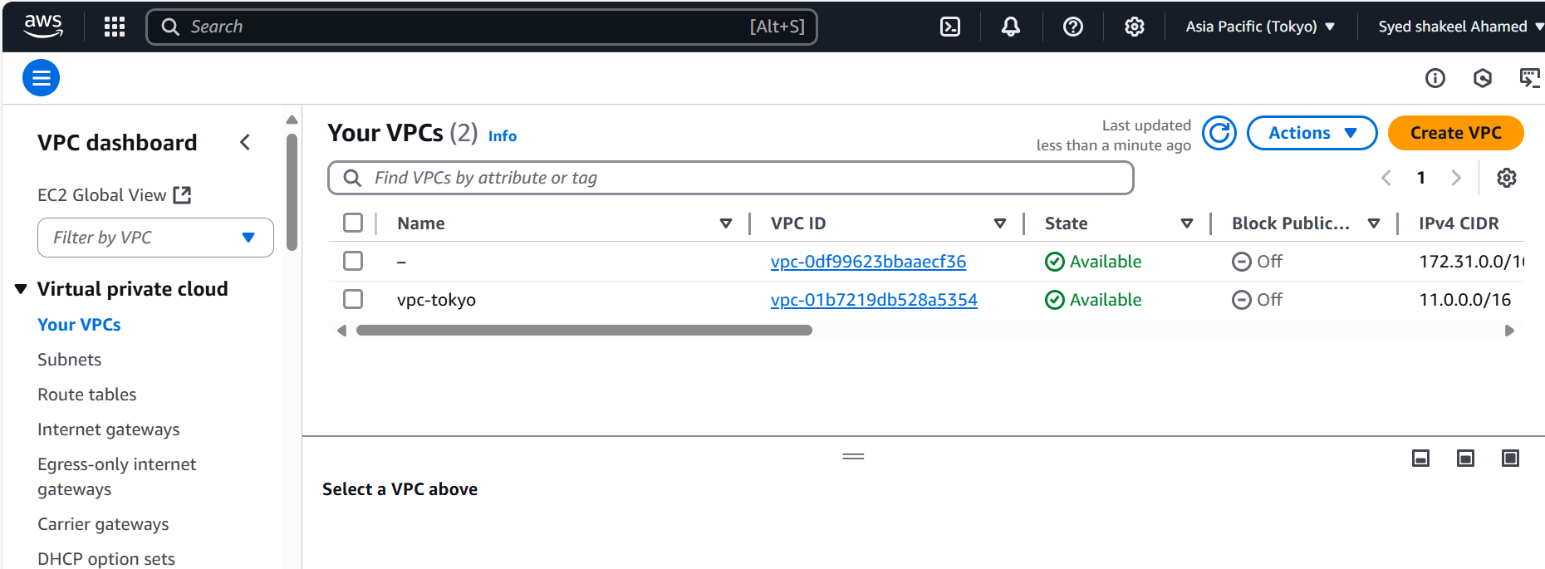

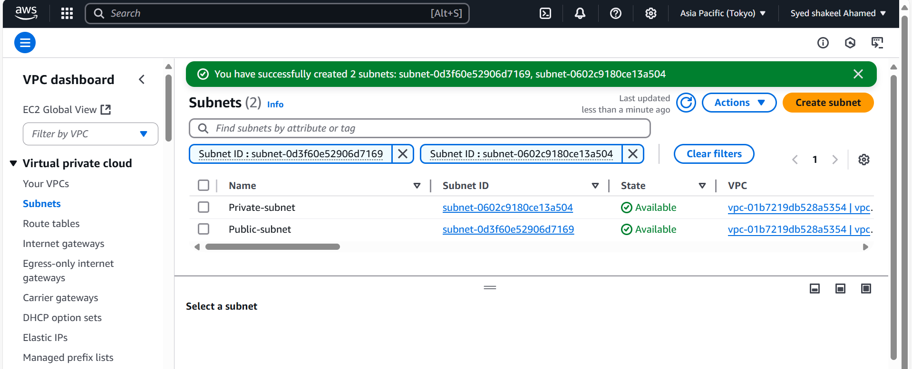

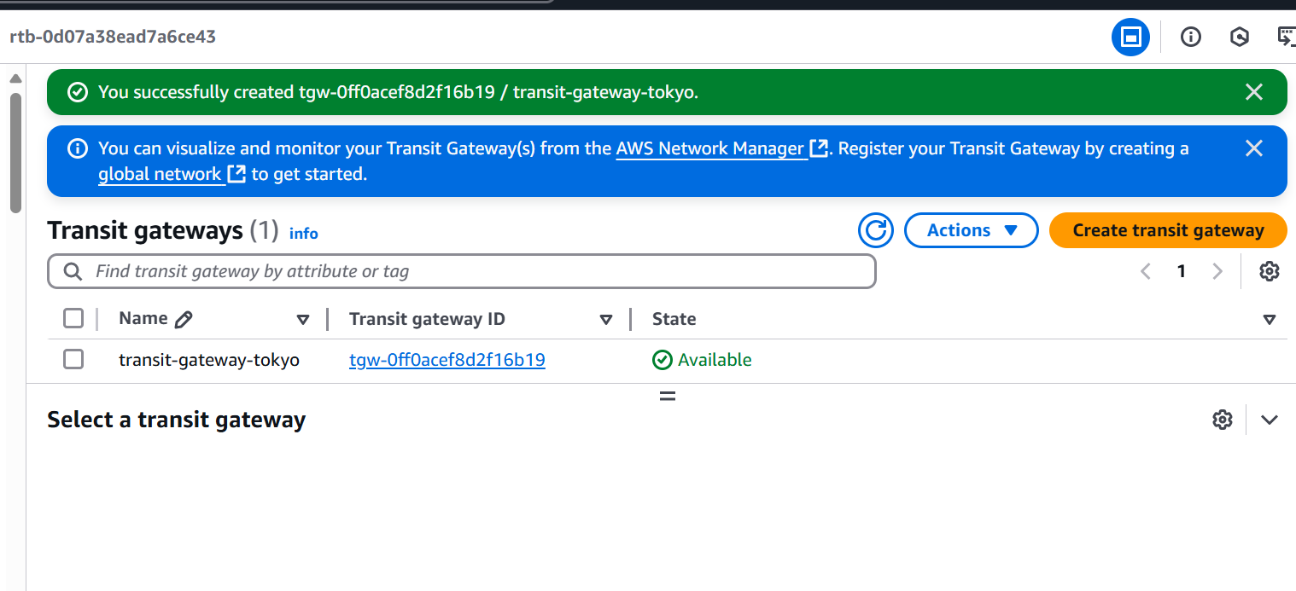

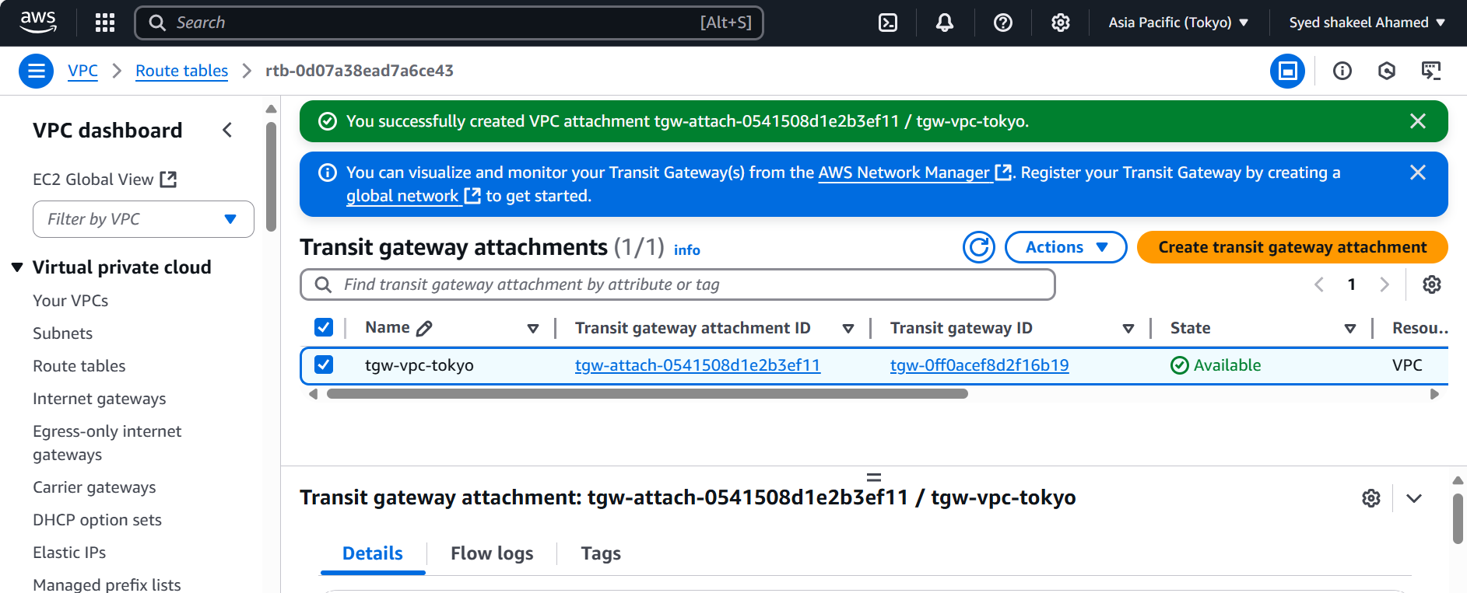

**Frankfurt eu-central-1**

Create VPC

Go to Amazon AWS console in that select VPC

select create VPC

Name: vpc-frankfurt

CIDR: 12.0.0.0/16

Create internet gateway and attach vpc created

Create Subnets:

Public subnet :12.0.1.0/24

Private subnet:12.0.2.0/24

Create Transit Gateway

Configure transit gateway with default ASN number 64514

Now go to Transit Gateway attachments and create 1 attachment with created vpc-frankfurt

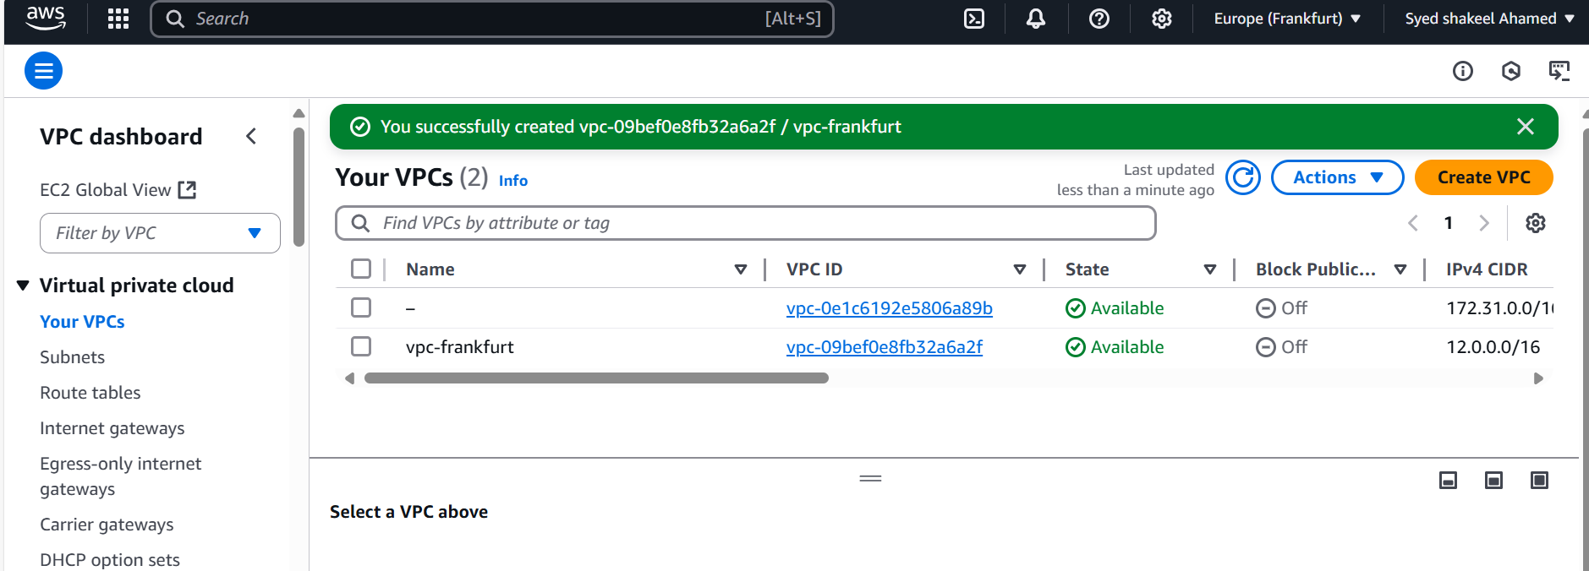

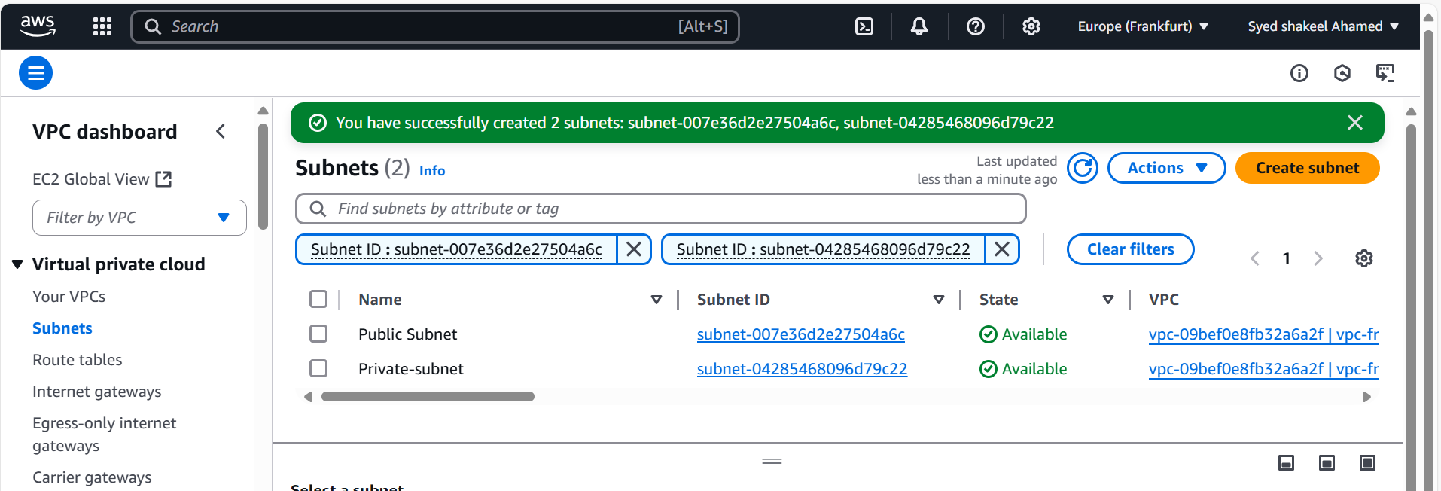

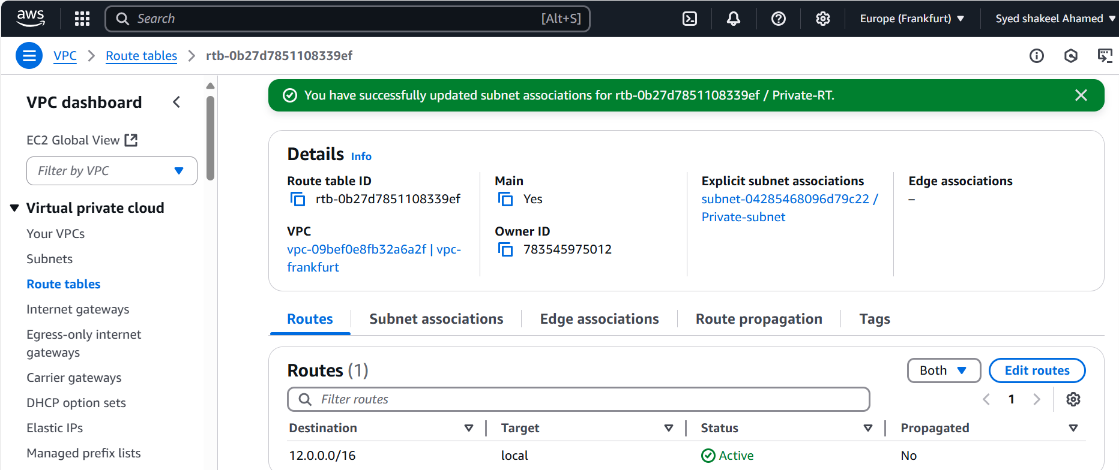

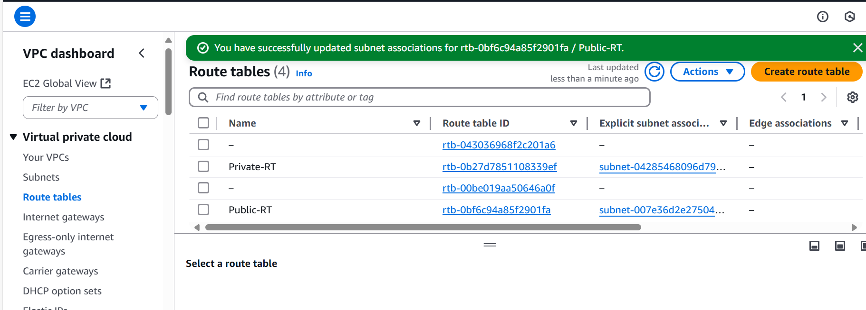

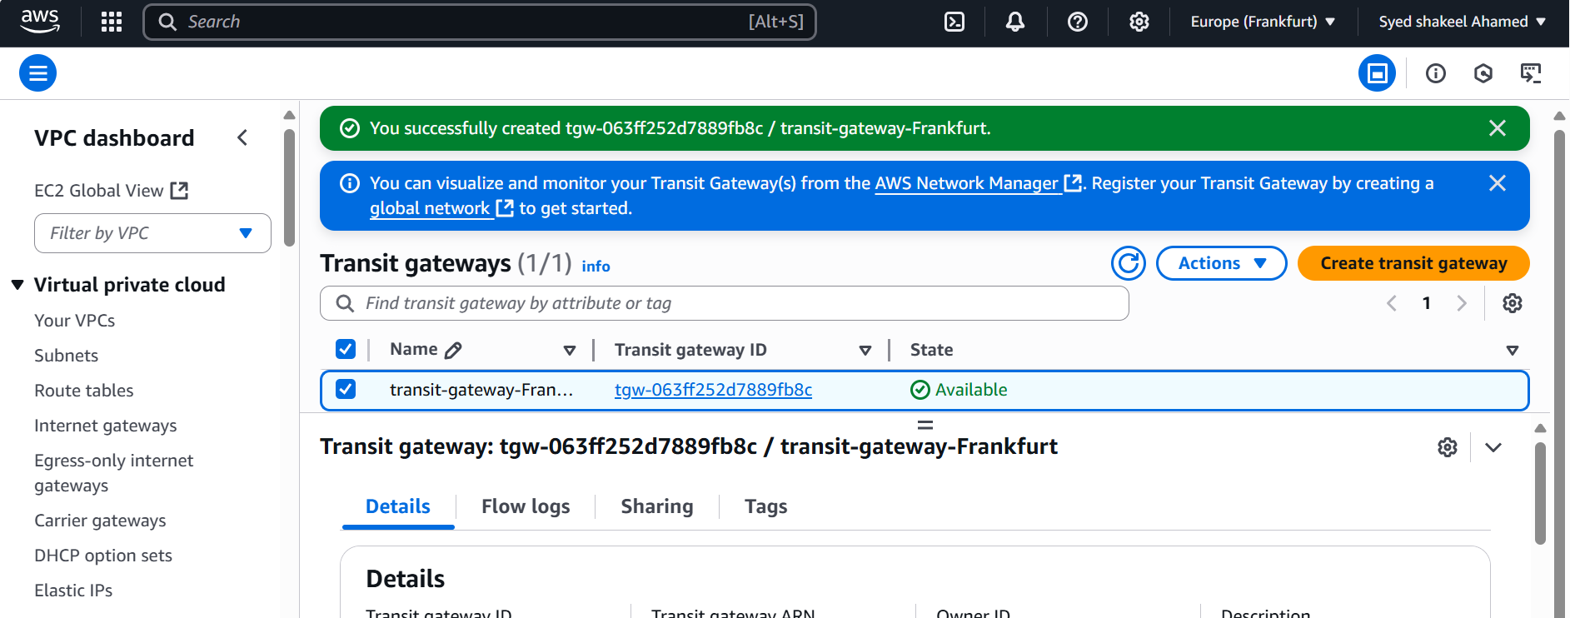

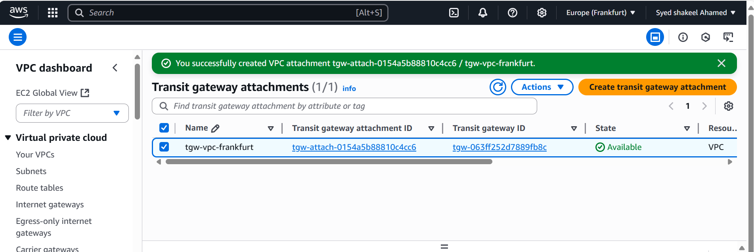

**Paris eu-west-3**

Create VPC

Go to Amazon AWS console in that select VPC

select create VPC

Name: vpc-Paris

CIDR: 13.0.0.0/16

Create internet gateway and attach vpc created

Create Subnets:

Public subnet :13.0.1.0/24

Private subnet:13.0.2.0/24

Create Transit Gateway

Configure transit gateway with default ASN number 64515

Now go to Transit Gateway attachments and create 1 attachment with created vpc-Paris

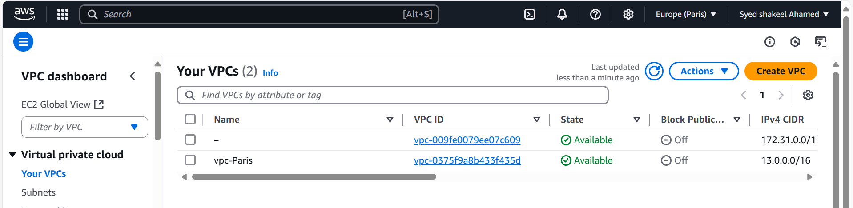

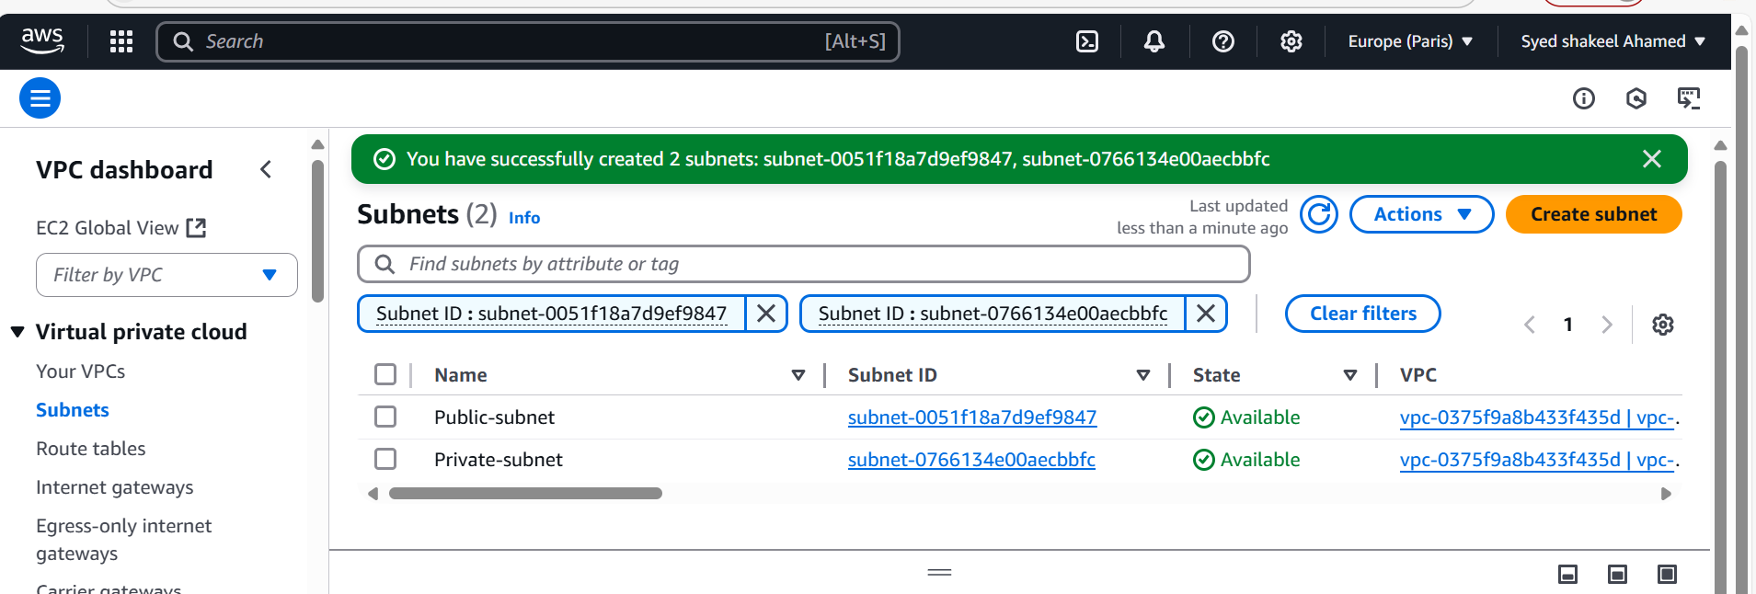

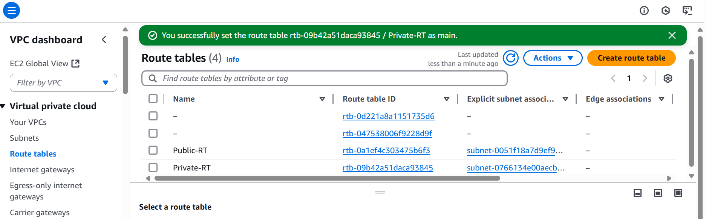

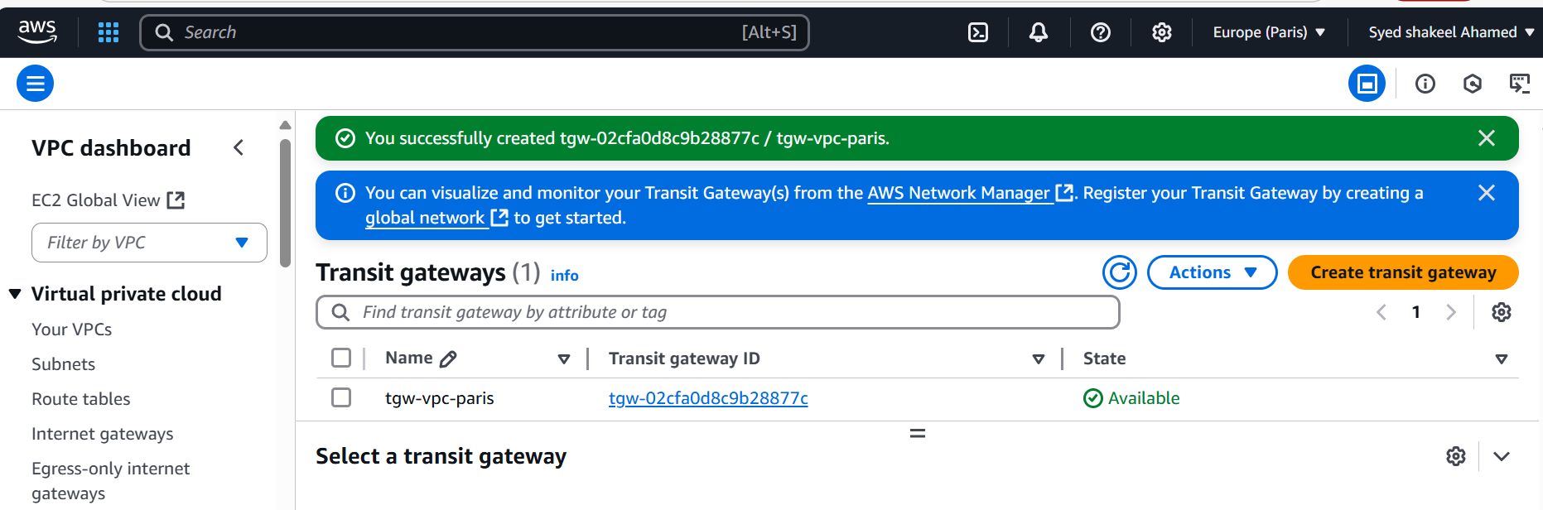

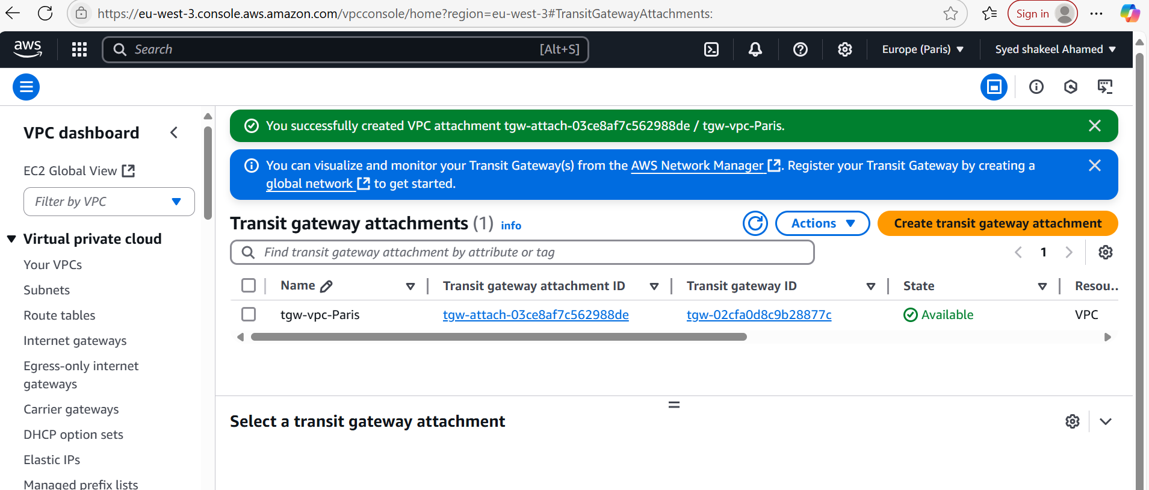

Multi-VPC-Peering-TGW

Create Transit Gateway

Configure transit gateway with default ASN number 64515

Now go to Transit Gateway attachments and create 1 attachment with created vpc-Paris

Now again select Oregon region

Go to Transit Gateway attachments

Create transit gateway attachment there select attachment type as peering select appropriate id and subnet ids

create vpc peering attachment

same repeat for other regions create transit gateway peering attachments with respective configurations

send the request to accept to peering for transit gateway and accept in respective regions

Now come to Transit gateway Route table

check for propagation is enabled for hub region

Now create the static Routes with resource as peering

11.0.0.0/16 transit gateway

12.0.0.0/16 transit gateway

13.0.0.0/16 transit gateway

Same repeat for other regions and create appropriate static routes

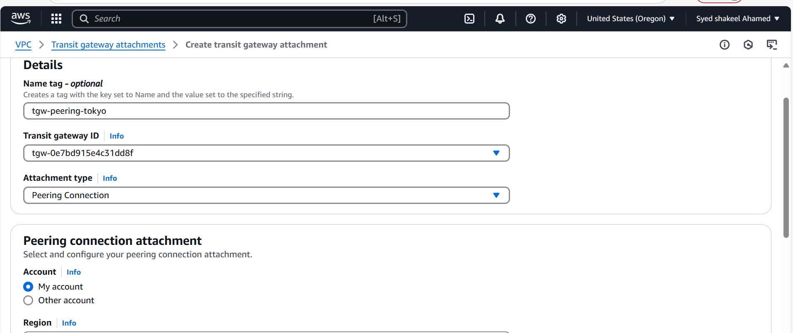

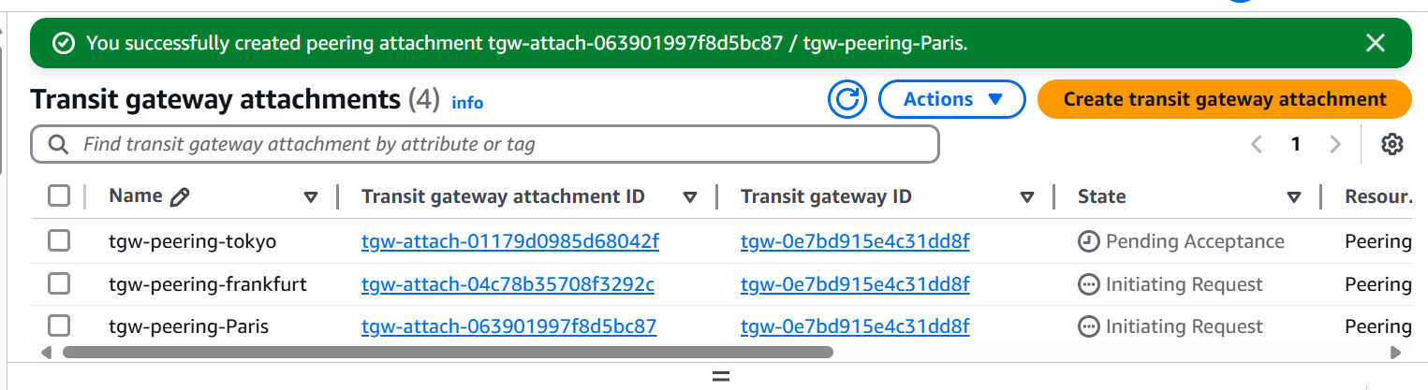

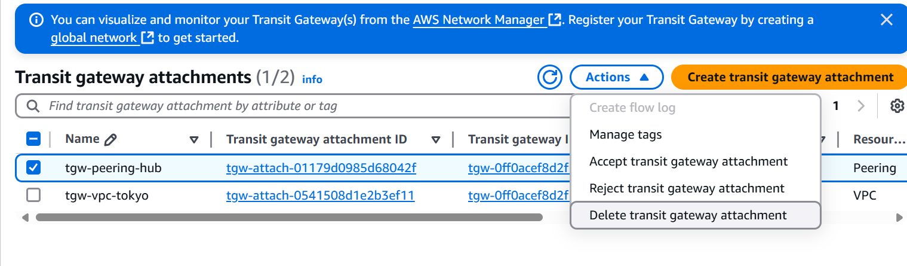

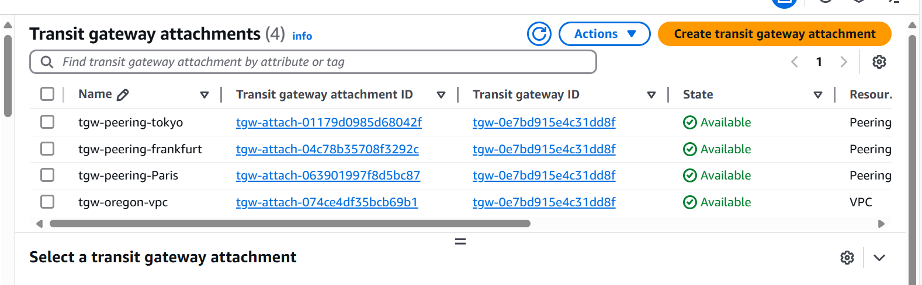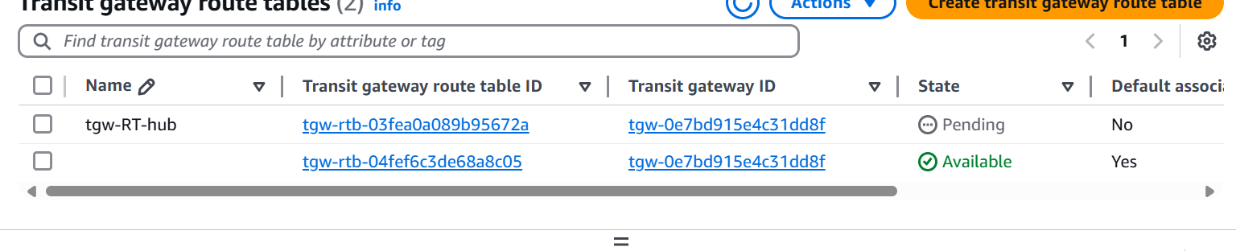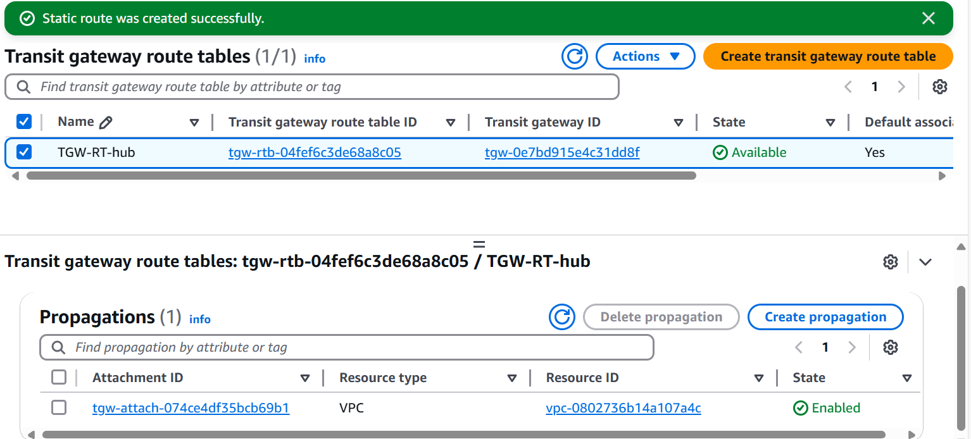

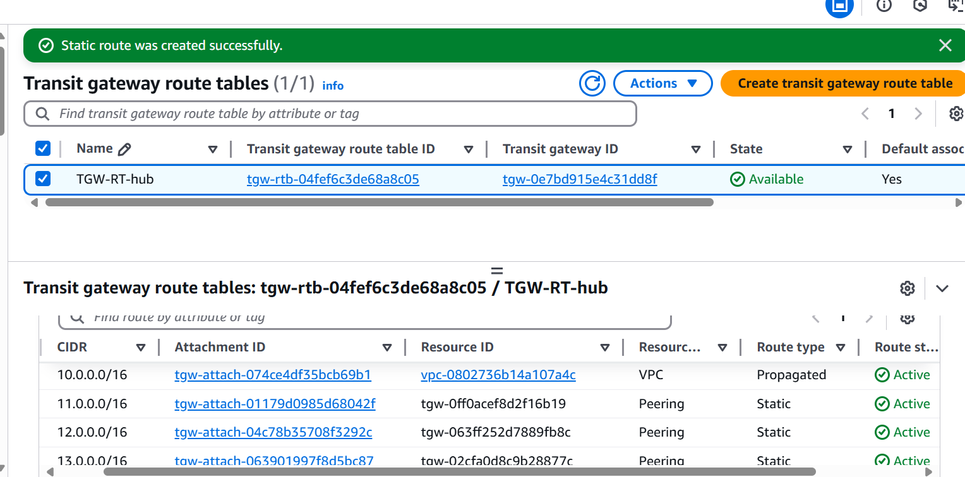

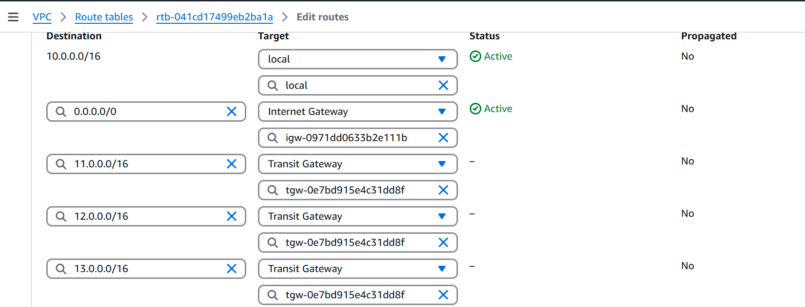

VPC-Endpoint

Now go to Oregon region vpc section

Select Endpoint

Create endpoint

Provide name

Service category as AWS service

Services select s3

Service name select appropriate option and type Gateway

Click on create Endpoint

Same procedure repeat for other regions also

Modifiy the Private Route table and check vpc endpoint in target section

Now we have created an endpoint attached to Private Route Table

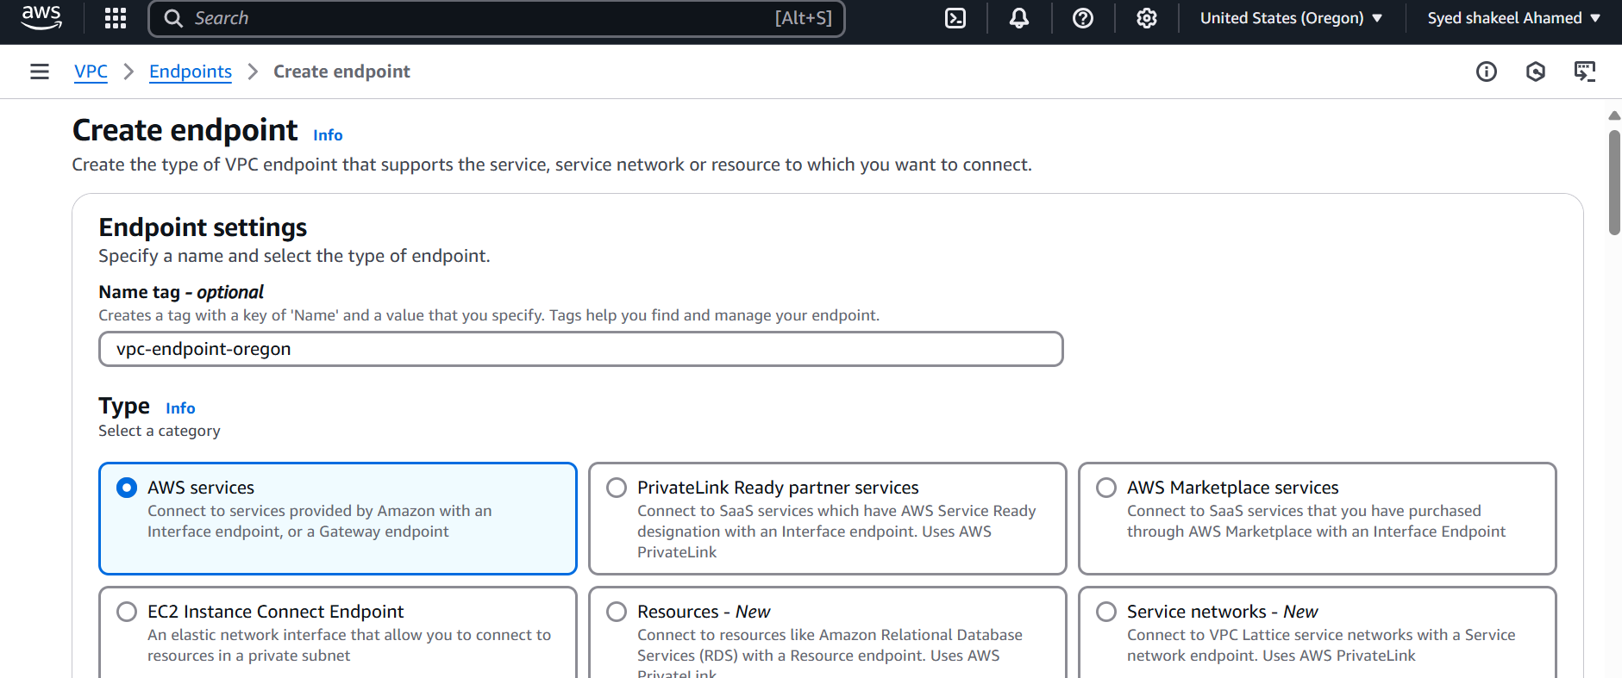

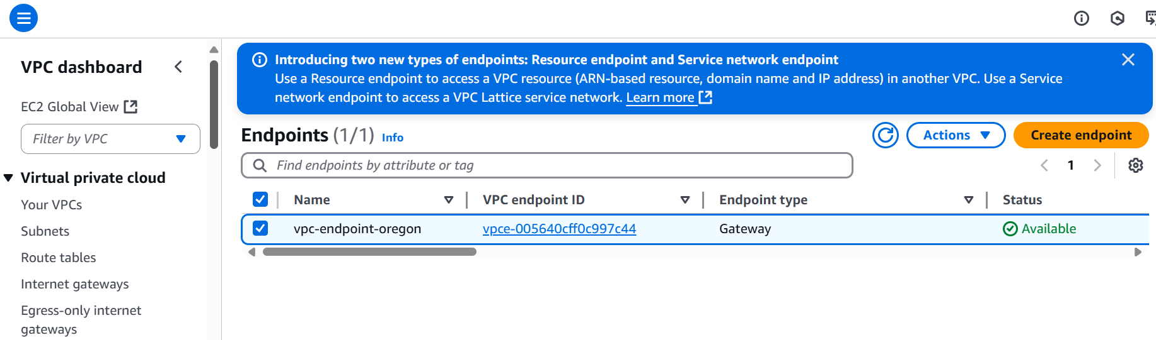

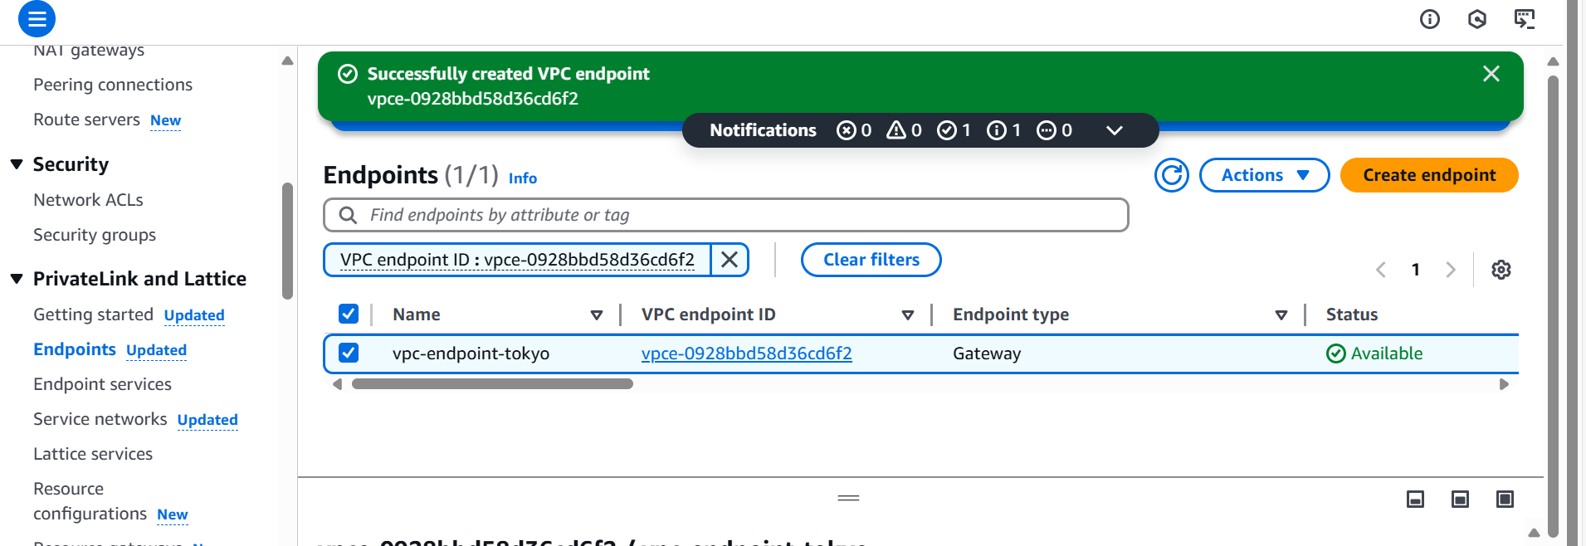

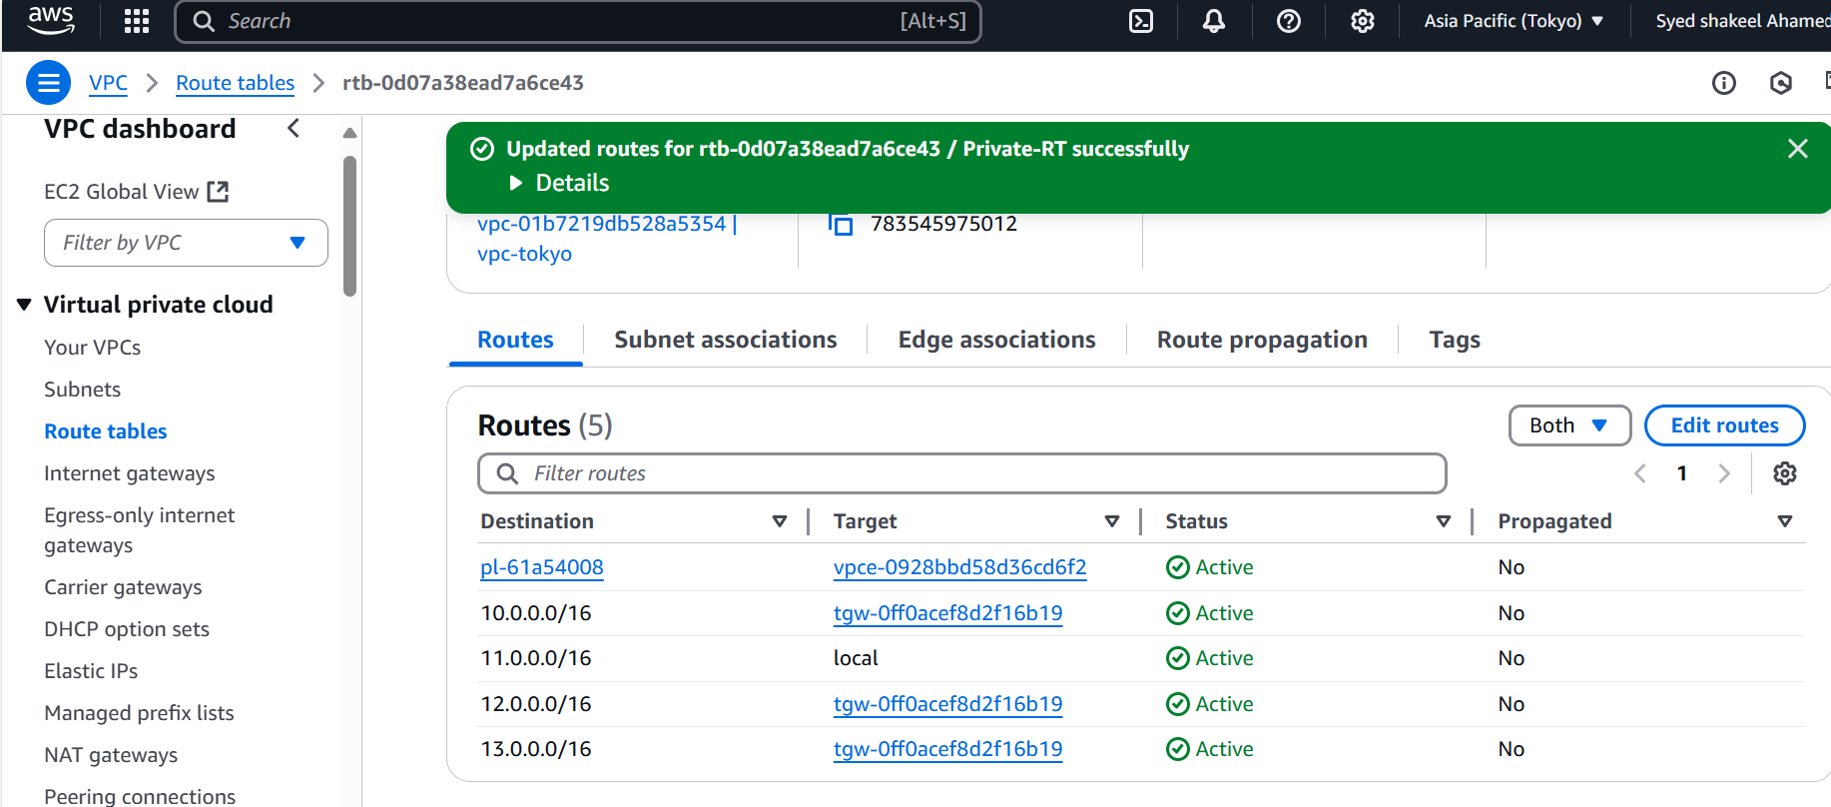

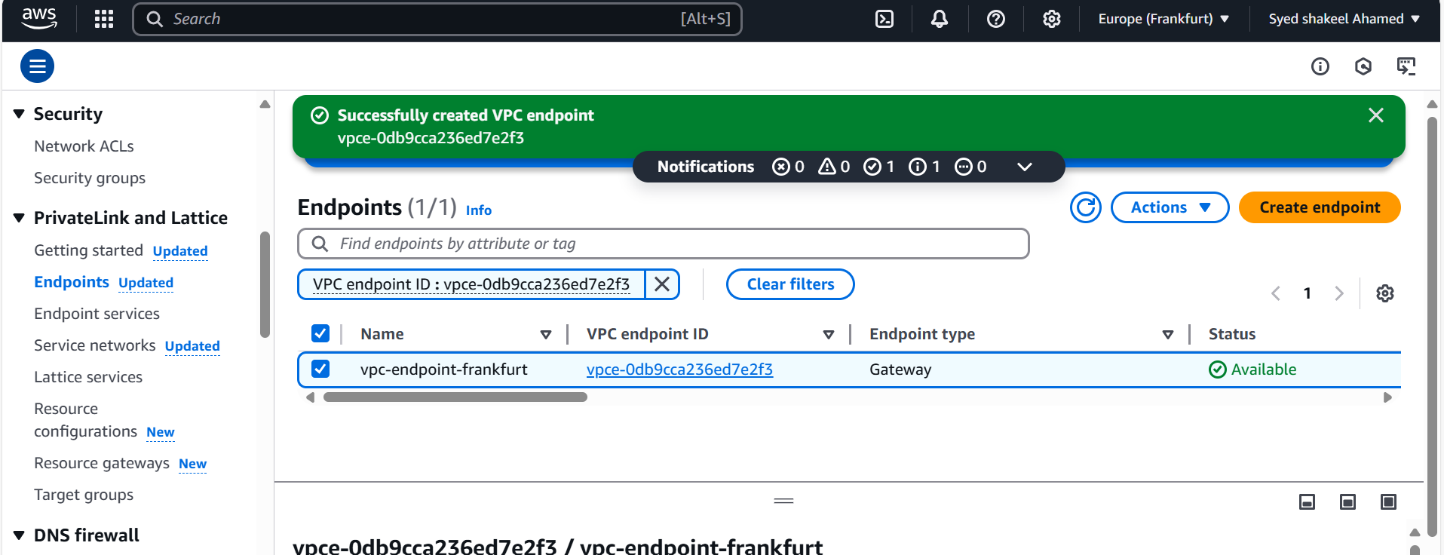

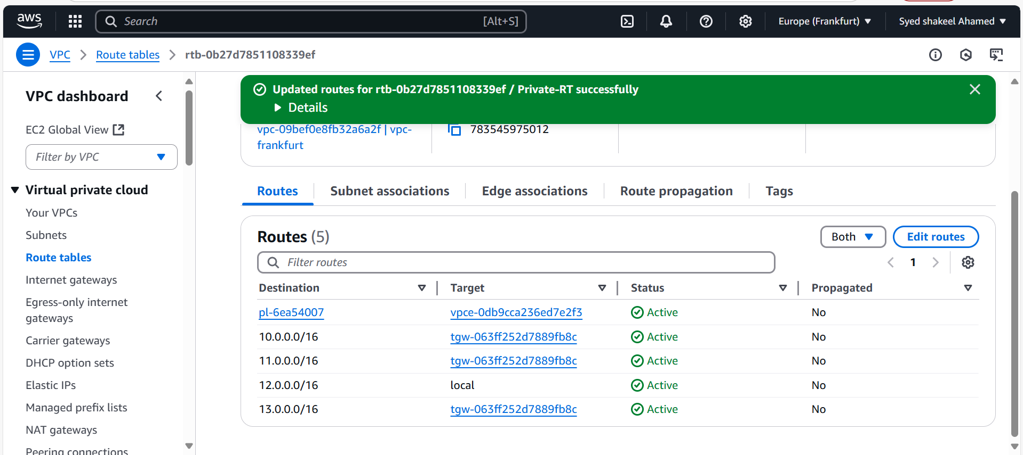

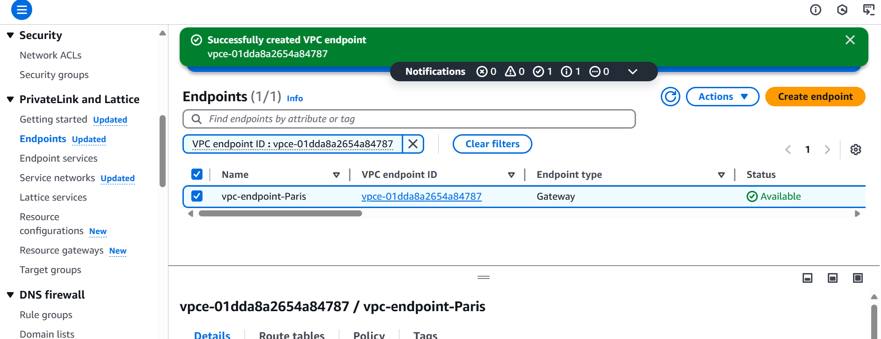

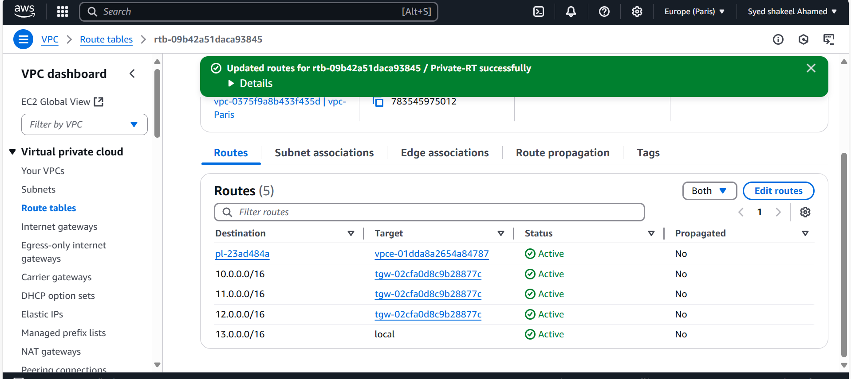

Now its time to launch the EC2 instances in AWS console

Paris-Ec2-instance

Now create the private ec2- instance in aws by selecting appropriate vpc created and subnet as private subnet and launch the instance.

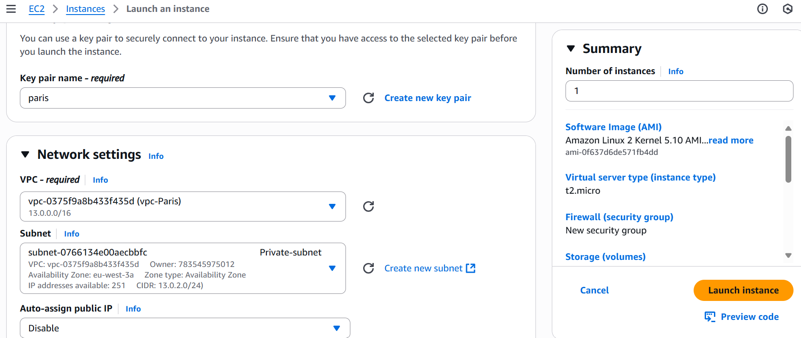

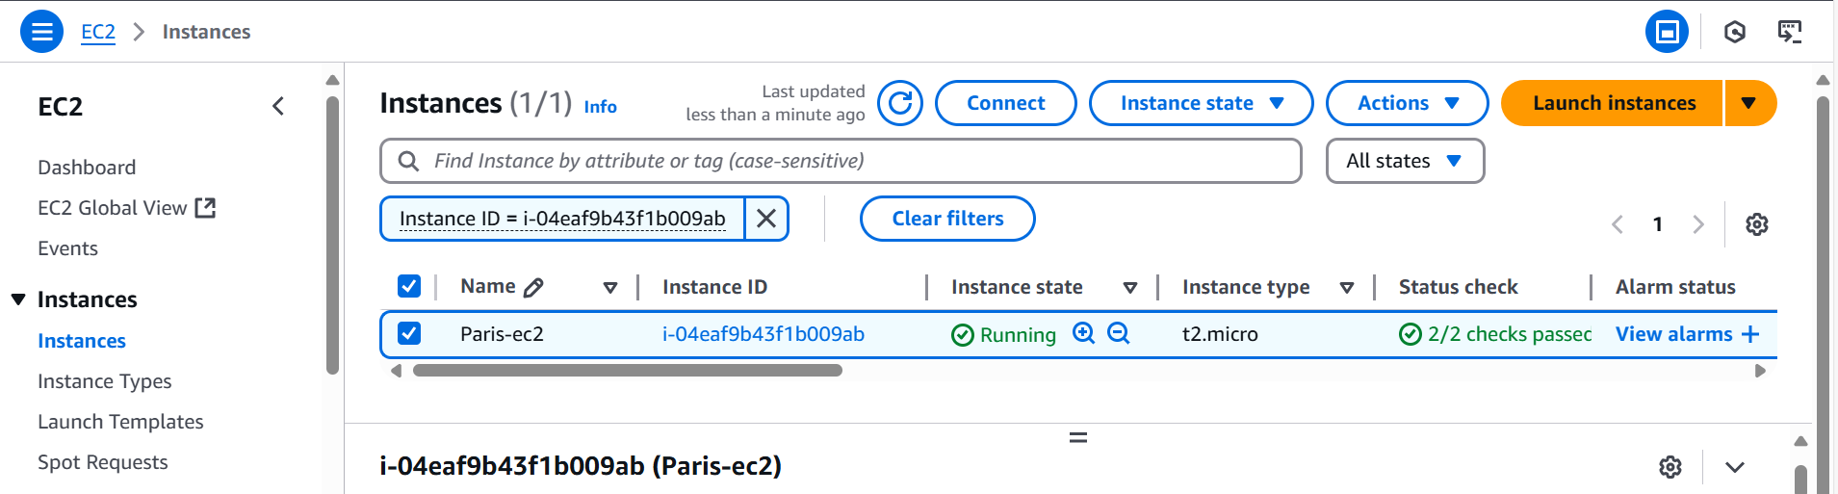

Frankfurt-Ec2

Now create the private ec2- instance in aws by selecting appropriate vpc created and subnet as private subnet and launch the instance.

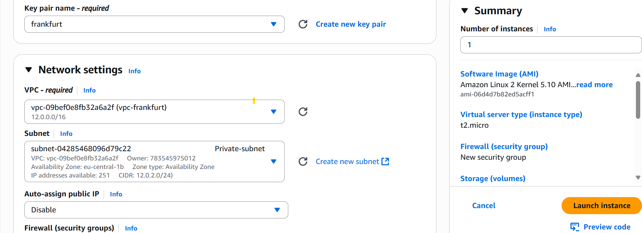

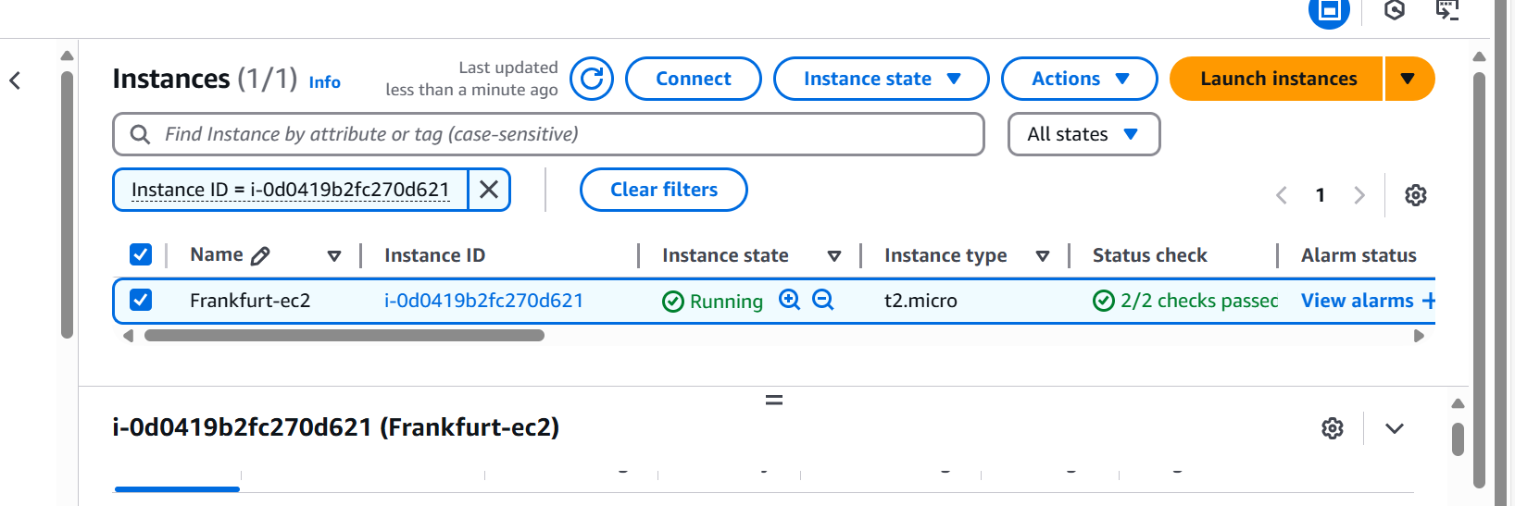

Tokyo-Ec2

Now create the private ec2- instance in aws by selecting appropriate vpc created and subnet as private subnet and launch the instance.

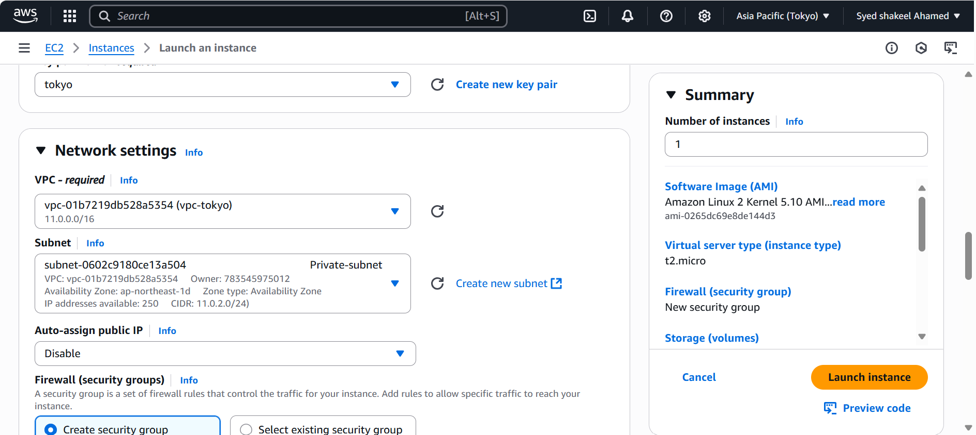

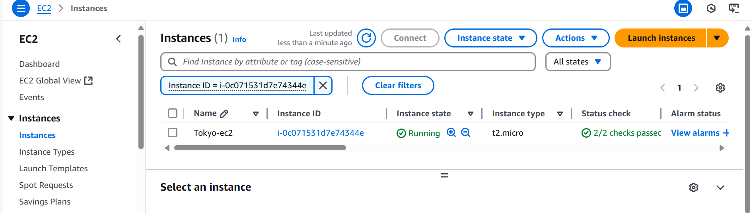

Oregon-Ec2-Hub

Now create the private ec2- instance and public instance in aws by selecting appropriate vpc created and subnet as private subnet and public subnet and launch the instance.

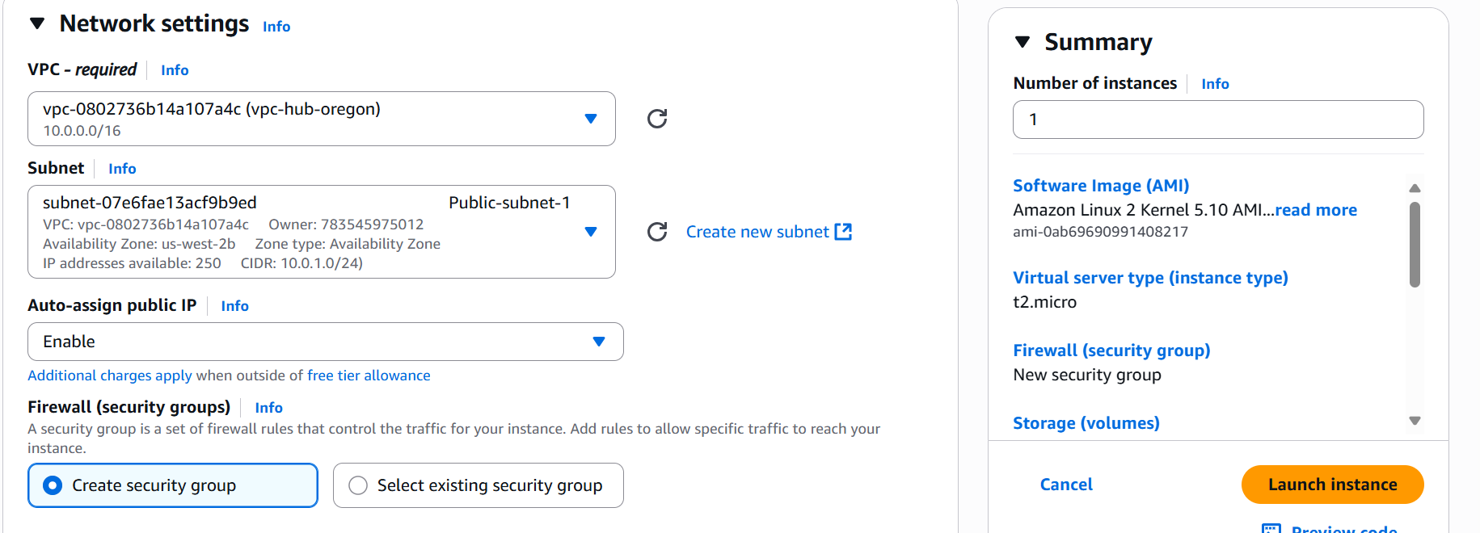

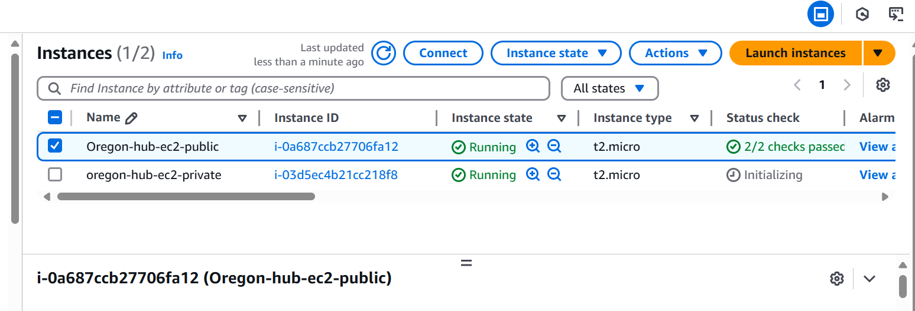

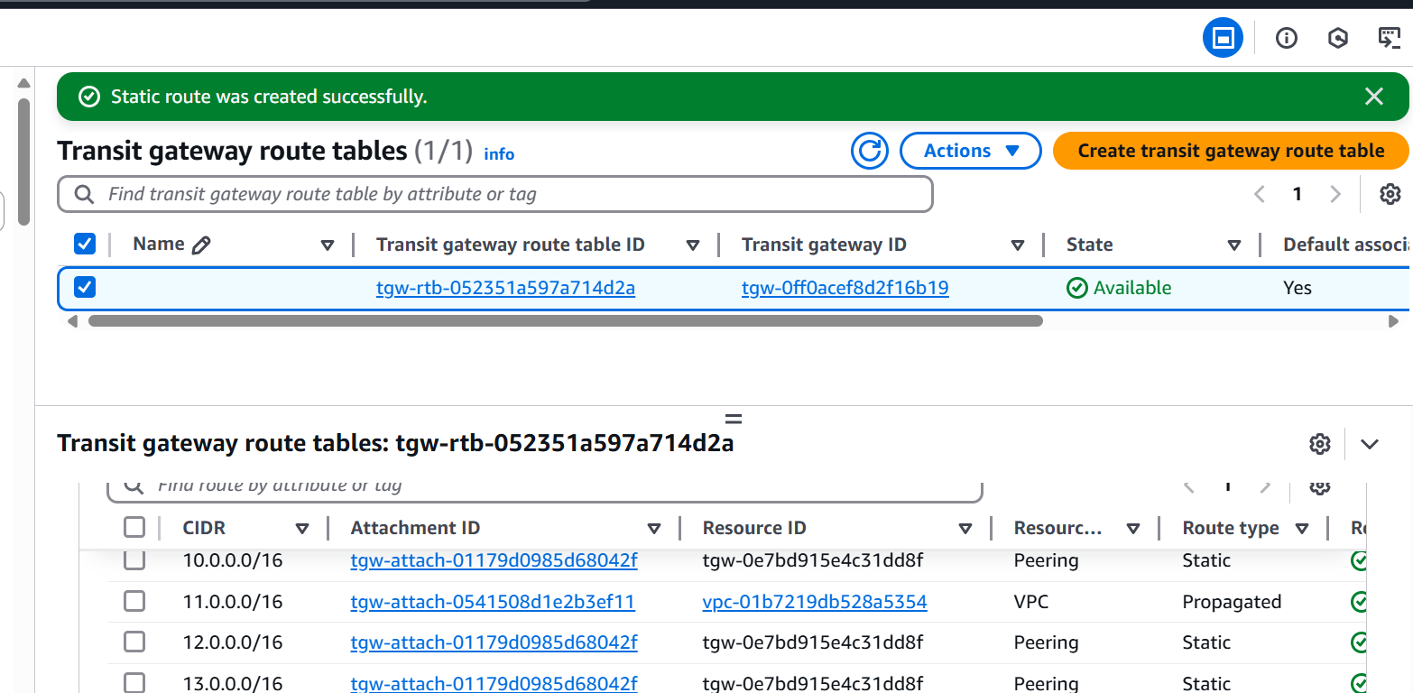

Now access CLI/Gitbash

Connect your Oregon (hub) public instance using ssh –i oregon.pem ec2-user@public ip

Once the connection is established check for remote connectivity of other region instances

Ping private ip of tokyo instance

Ping private ip of Frankfurt instance

Ping private ip of Paris instance

That means we have successfully Design and deploy a scalable network architecture using AWS Transit Gateway to simplify network connectivity between multiple VPCs

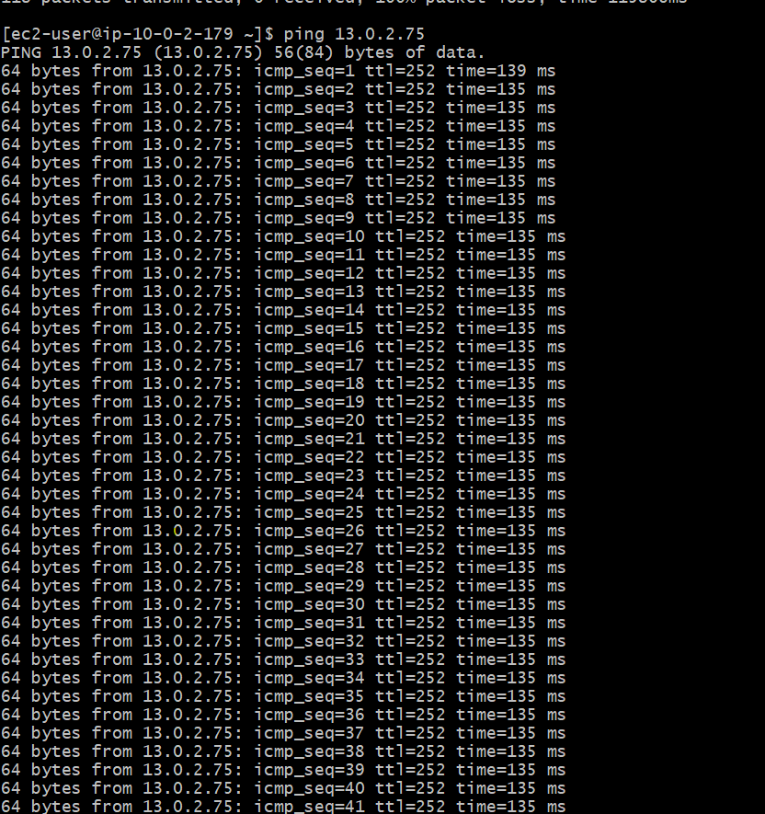

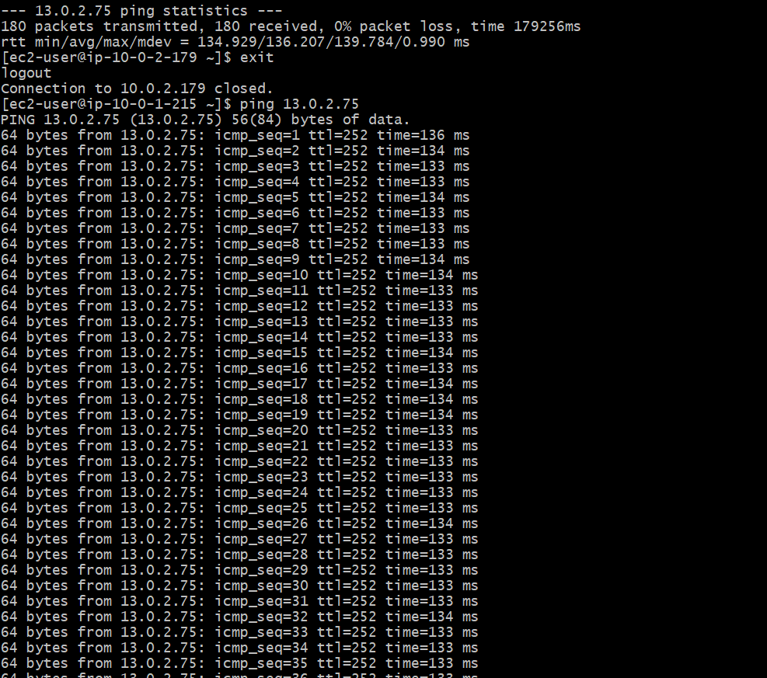

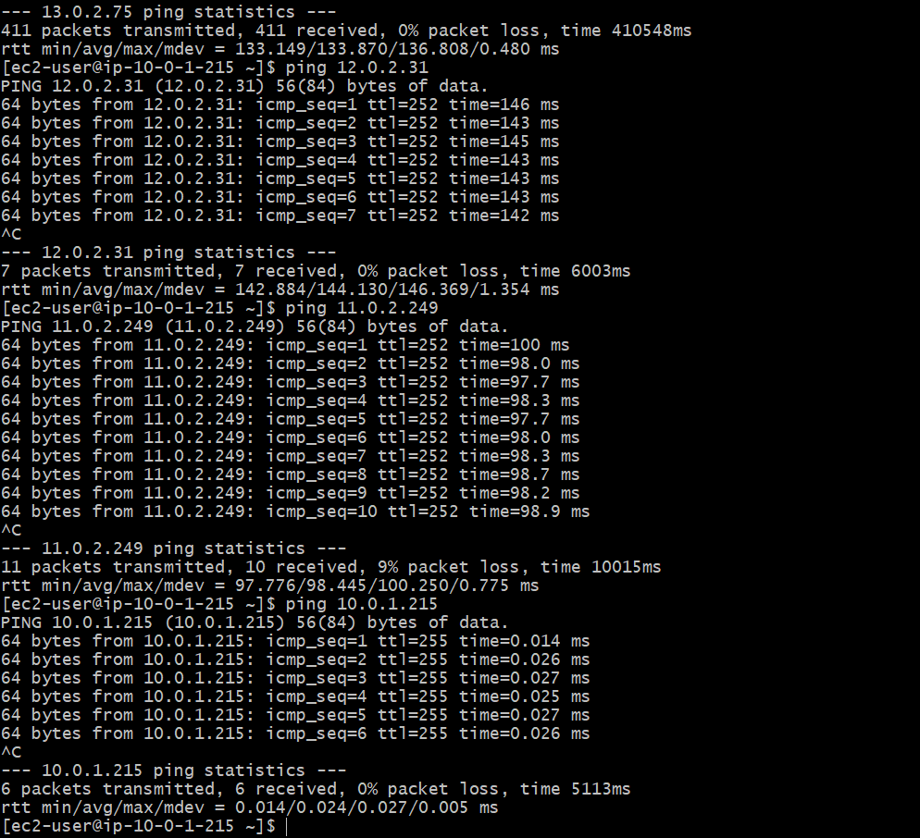

**Configure VPC endpoints to securely access AWS services without internet gateways or NAT gateways, ensuring data privacy and minimizing exposure to external threats**

VPC-Endpoint

Now go to Oregon region vpc section

Select Endpoint

Create endpoint

Provide name

Service category as AWS service

Services select s3

Service name select appropriate option and type Gateway

Click on create Endpoint

Same procedure repeat for other regions also

Modifiy the Private Route table and check vpc endpoint in target section

Now we have created an endpoint attached to Private Route Table

















VPC-endpoint

In Gitbash

Ssh –i .pem ec2-user@public_ip

Once the connection is establised use Bastian server to connect from Private EC2 of other regions

Cat oregon.pem

Copy the pem key

Create a new file

Vi test.pem

Copy and save the file with pem key

Chmod 400 test.pem

Now try to connect with private ec2

Ssh –i test.pem ec2-user@private-ip of private ec2’s of other region one by one

Once we logged in successfully

Use aws configure

Access_key

Secret_key

Region: Enter respected regions

Output: json

Now check for aws s3 ls

Because of internet access and we have created vpc endpoints we will get the output of aws s3 ls aws service

Communication has been successfully processed.

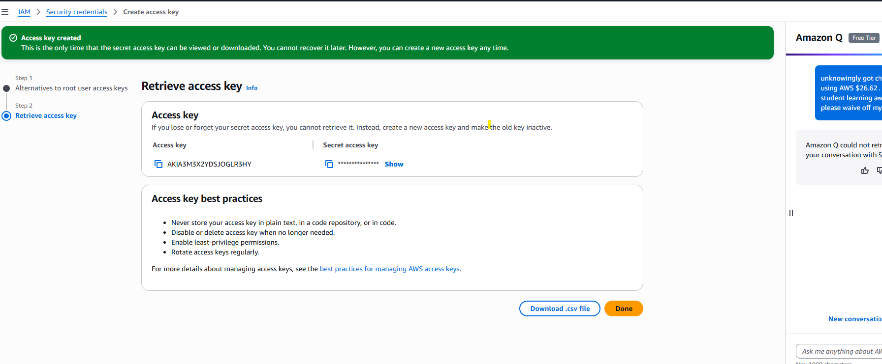

Tokyo

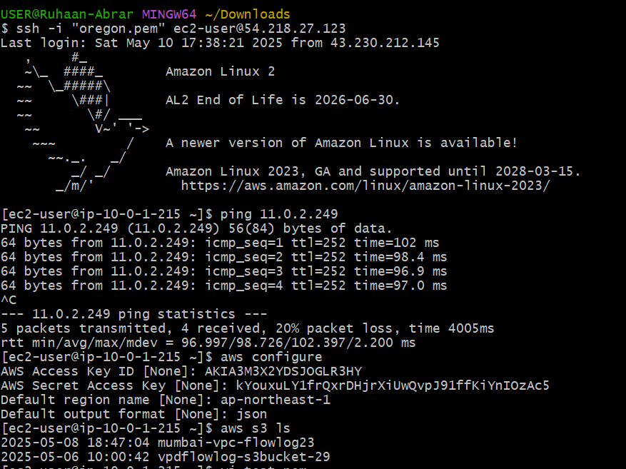

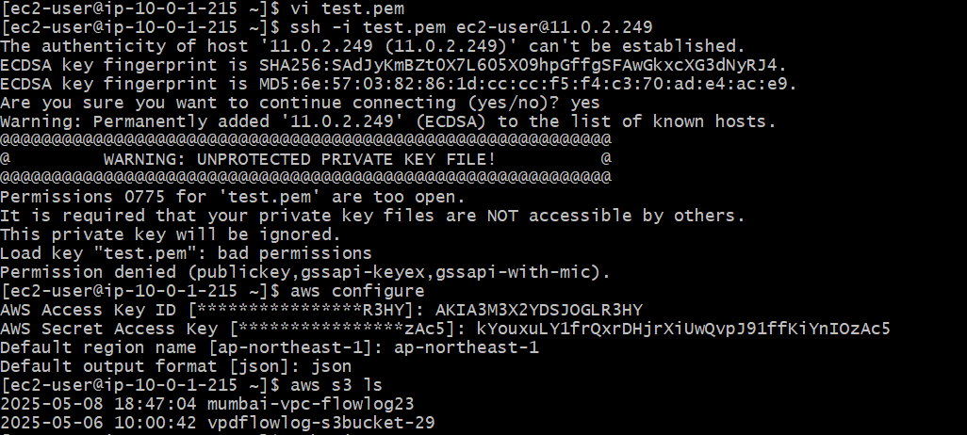

Frankfurt

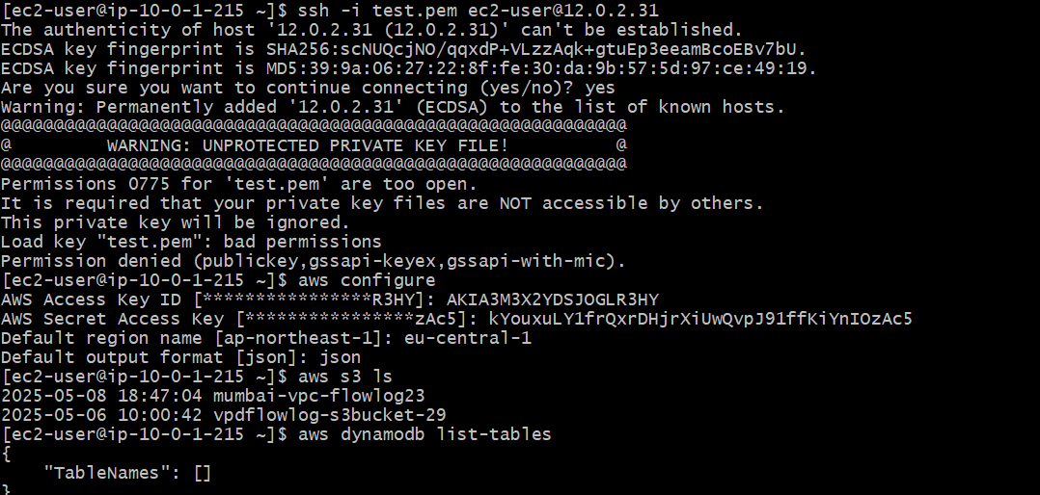

Paris

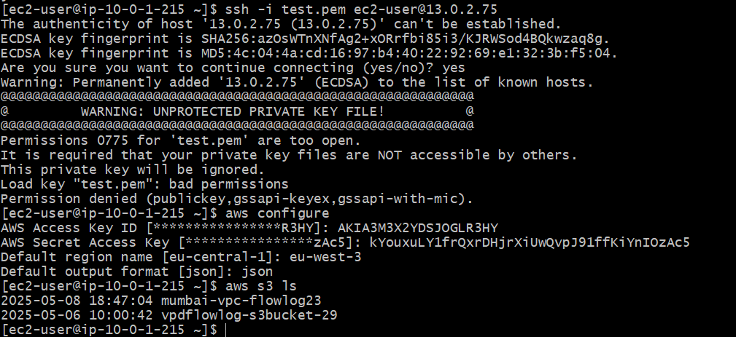

VPC Flow logs

It will help us to monitor our created VPCs

Traffic which is flowing to VPC will capture by VPC flowlogs

VPC-Flowlogs creation

Vpc flowlogs

Filter (accept/reject/all

Maximum aggregation interval as 1 min

Destination: where we want to save the logs

Please selct sent to Amazon S3 bucket

S3 is one of the storage available in AWS

Create S3 bucket

Bucket name give some unique name

AWS region

Object ownership : ACLS enabled

Create the bucket by selecting appropriate options

Copy the ARN (amazon Resource number)

Log record format : AWS default format

Log file format : Text

Click on create flow log

Now check the flow logs by checking tar file which you have downloaded.

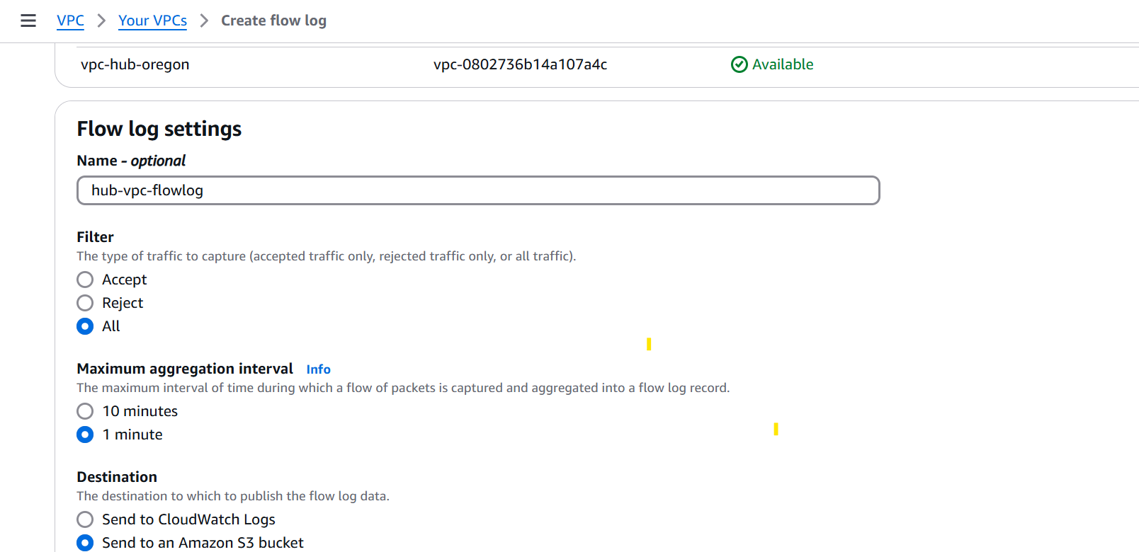

Creating S3 bucket

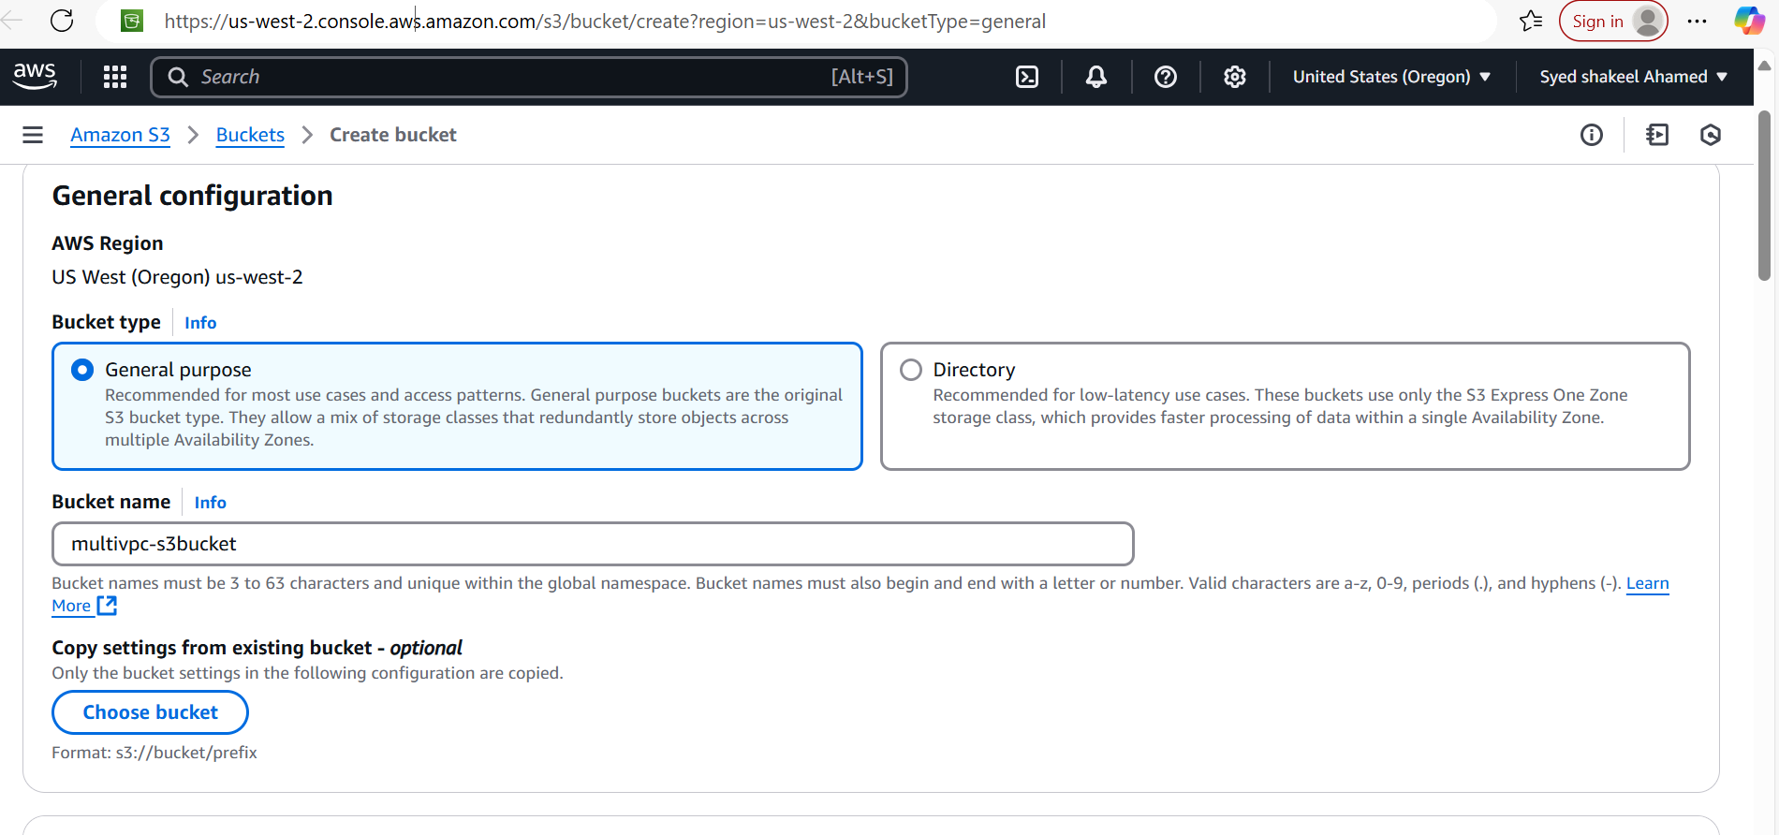

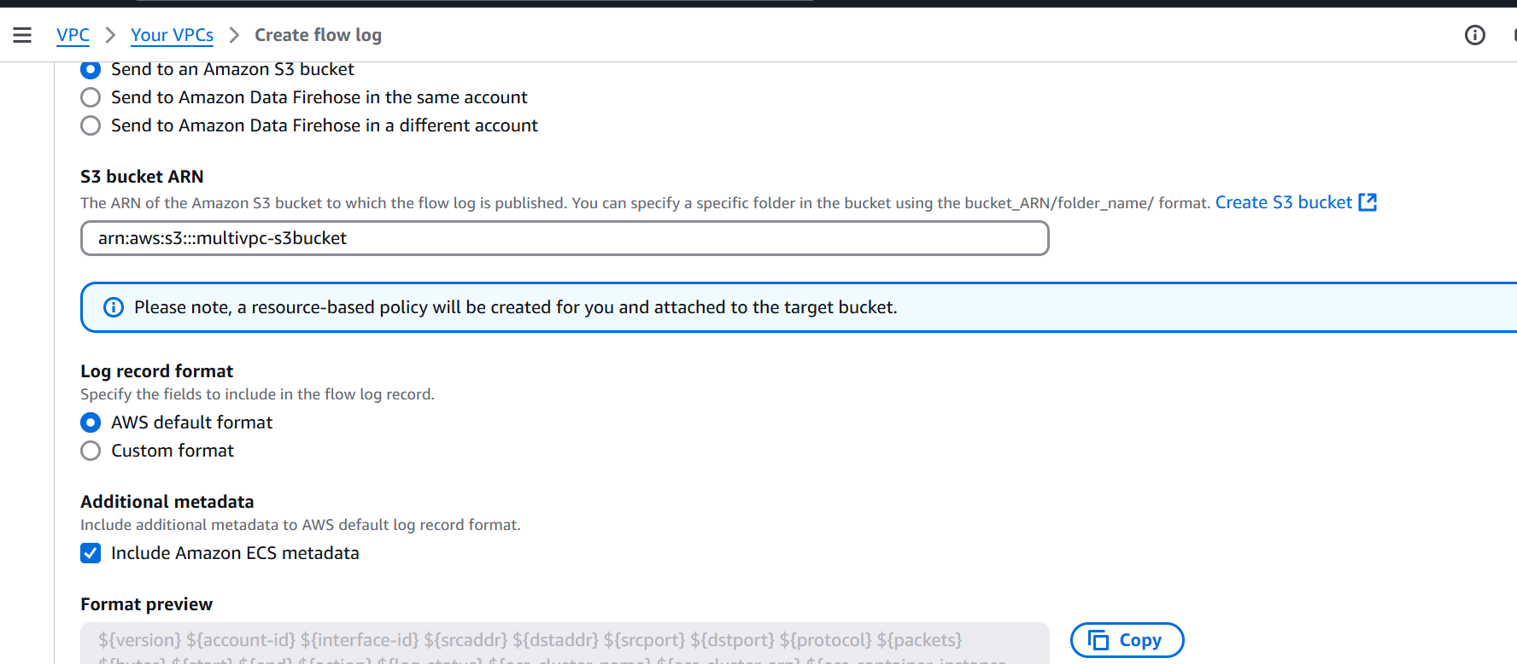

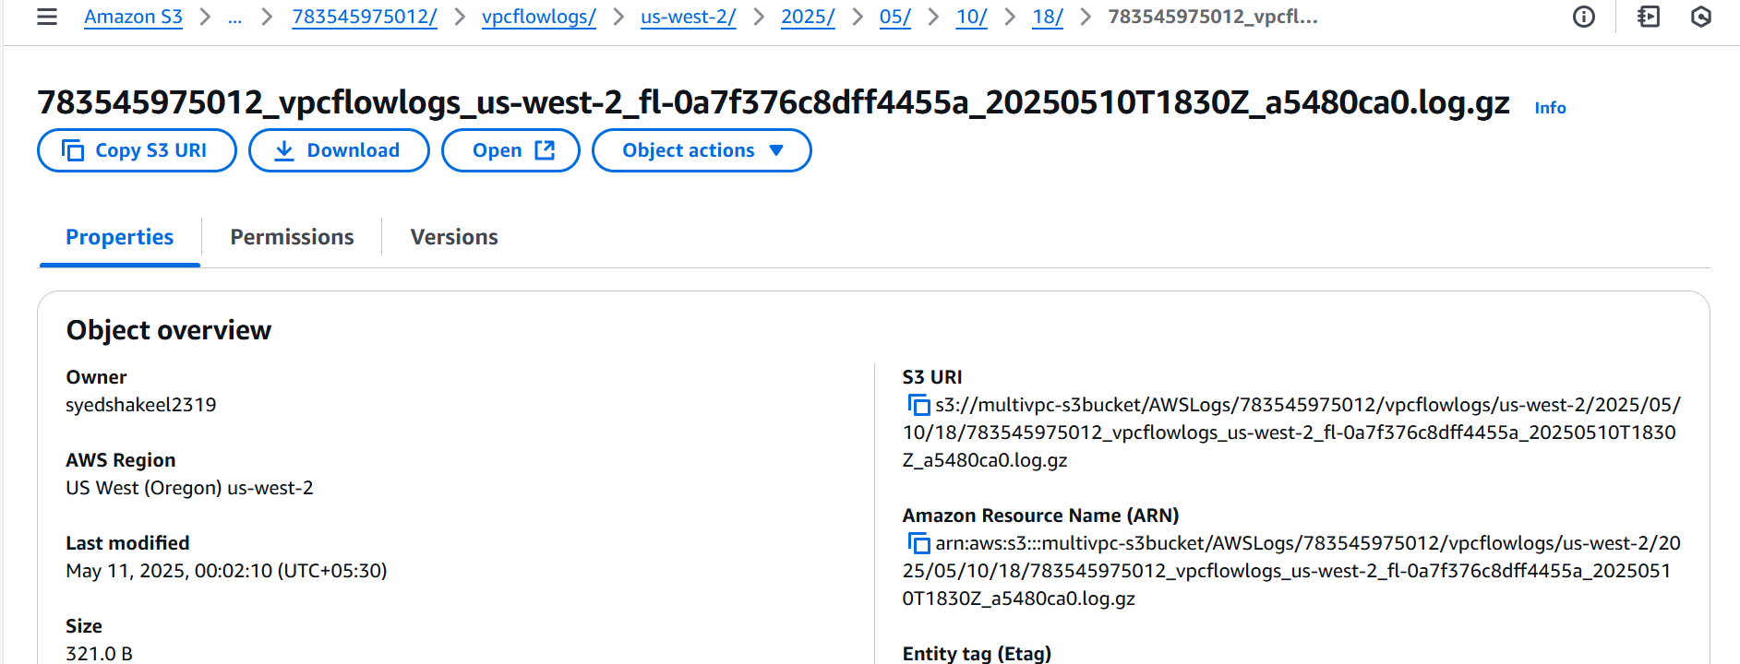

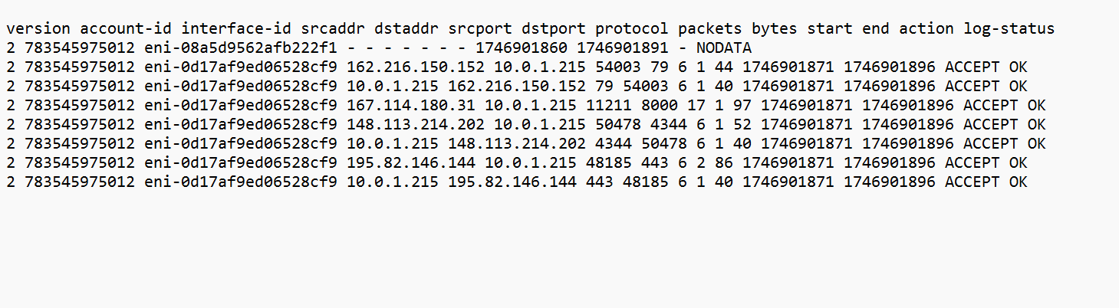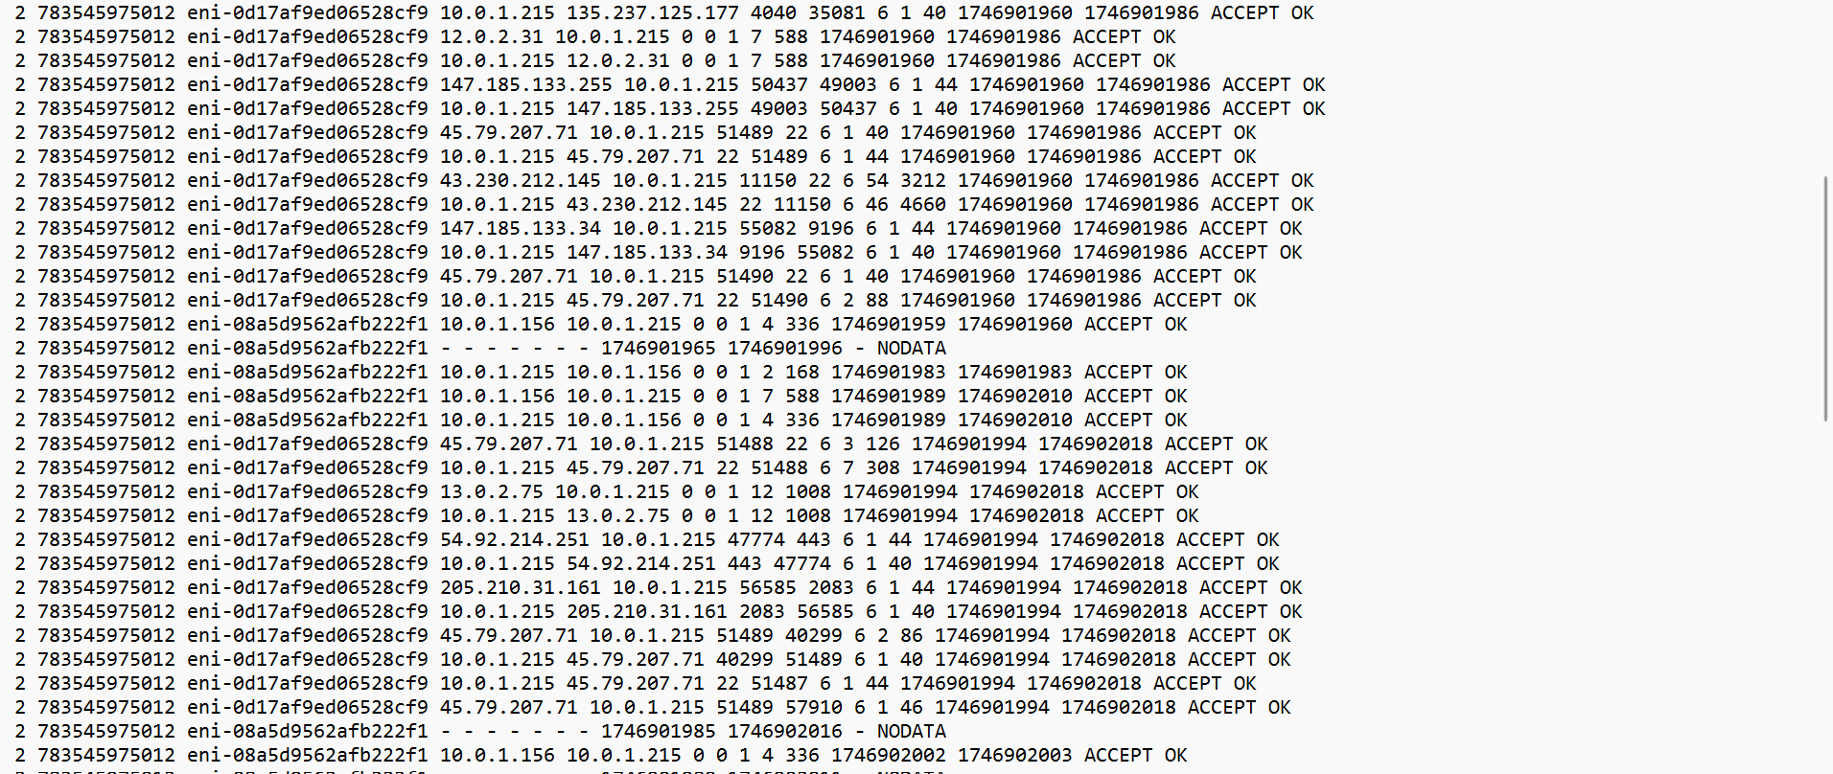

We have successfully configured VPC endpoints to securely access AWS services without internet gateways or NAT gateways, ensuring data privacy and minimizing exposure to external threats